# EZ FIX

## PROJECT REPORT

Submitted in partial fulfillment of the requirements for the award of the degree of

### BACHELOR OF SCIENCE (COMPUTER SCIENCE)

**SUBMITTED BY**

### MOHAMED NIHAL E(BLAVSCS022)

**UNDER THE GUIDANCE OF**

## Mrs. SHIBINA KP

(Asst. Prof. of the Department of Computer Science)



### BLOSSOM ARTS AND SCIENCE COLLEGE KONDOTTY,VALIYAPARAMBA(P.O)

**2021-2024**

# BLOSSOM ARTS AND SCIENCE COLLEGE

### KONDOTTY,VALIYAPARAMBA(P.O)



**BONAFIED CERTIFICATE**

This is to certify that the project report titled “**EZ FIX**” is a benifited certificate to work done by **MOHAMED NIHAL E(BLAVSCS022) at BLOSSOM ARTS AND SCIENCE COLLEGE VALLYAPARAMBA , KONDOTTY** during the year 2021-2024 in a partial fullfilment for the award of the degree of BACHLOR OF COMPUTER SCIENCE.

#### Head of Department

#### Internal Guide

**Place: External Examiner**

#### Date: 1.

**2.**

**DECLARATION**

I hereby declare that the project entitled "**EZ FIX**" is the project work done at the college **BLOSSOM ARTS AND SCIENCE COLLEGE,KONDOTTY** and submitted **UNIVERSITY OF CALICUT** in partial fulfillment of the requirement for the award of **BACHELORS DEGREE IN COMPUTER SCIENCE** and is original work done by me during the period of study (2021-2024) under the supervision and guidance of **Mrs. SHIBINA KP** This project work has not formed the basis for the award of any degree/associate- ship/fellowship or similar title to any candidate of any University.

#### Place: KONDOTTY MOHAMED NIHAL E (BLAVSCS022)

**Date:**

**ACKNOWLEDGEMENT**

I feel a great sense of accomplishment having completed this project, and I’m proud of the hard work and dedication that went into it.

I wish to thank our respected Principal **Dr. T.P AHAMMED** for providing all facilities to carry out this project work.

With great respect I express my sincere thanks to **Mrs. SHIBINA KP**, Asst Prof of the Department of **Computer Science**, Blossom Arts and Science College, for providing the facilities for the successful project completion and for guidance, expert advice and valuable assistance for the successful completion of our project.

I’m very much thankful to all other staff members for their valuable help. Last but not least I would like to thank all our friends who have helped for the successful completion of the project.

#### Place: KONDOTTY MOHAMED NIHAL E (BLAVSCS022)

**Date:**

CONTENT

**CHAPTER NO CONTENT TOPIC PAGE NO**

1. INTRODUCTION 8
2. SYSTEM STUDY 10
   1. EXISTING SYSTEM 11
   2. DISADVANTAGES OF 11

EXISTING SYSTEM

* 1. PROPOSED SYSTEM 12
  2. ADVANTAGES OF 13

PROPOSED SYSTEM

* 1. PROBLEM DEFINITION 14

1. SYSTEM ANALYSIS 16

|  |  |  |  |
| --- | --- | --- | --- |
|  | | **3.1 SYSTEM CONFIGURATION** | **17** |
| * 1. **SOFTWARE REQUIRMENT SPECIFICATION**   2. **FEASIBILITY STUDY** | **18**  **19** |
| **4** |  | **SYSTEM DESIGN 24** | **24** |
|  |  | **4.1 INITIAL DESIGN** | **25** |
|  |  | **4.2 DATA FLOW DIAGRAM** | **26** |
|  |  | **4.3 DATABASE DESIGN** | **28** |
|  |  | **4.4 TABLE DESIGN** | **29** |
|  |  | **4.5 INPUT DESIGN** | **33** |
|  |  | **4.6 OUT DESIGN** | **35** |
| **5** |  | **SYSTEM DEVELOPMENT** | **36** |
|  |  | * 1. **FEATURES OF FRONT END AND BACK END**   2. **PROJECT PLANNING** | **37**  **48** |
|  |  | **5.3 PROJECT SCHEDULING** | **48** |
|  | **6** | **SYSTEM TESTING** | **50** |
|  |  | **6.1 TYPE OF TESTING** | **51** |
|  |  | **6.2 TESTING STRATEGY** | **55** |

**7 SYSTEM IMPLEMENTATION 57**

#### MAINTENANCES AND 60

#### SECURITY

#### SYSTEM MAINTENANCE 61

#### SYSTEM SECURITY 61

#### CONCLUSIONS 62

#### SCOPE FOR FUTURE 63

#### ENHANCEMENT

#### BIBLIOGRAPHY 64

#### APPENDIX 65

**ABSTRACT**

This abstract introduces "EZ FIX," an innovative online servicing app designed to streamline and simplify electronics repair and maintenance. EZ FIX offers users a convenient platform to connect with certified technicians for repairing a wide range of electronic devices, including smartphones, laptops, tablets, and gaming consoles. Through the app, users can schedule appointments, track repair progress in real-time, and communicate directly with technicians, ensuring a transparent and efficient repair process. EZ FIX prioritizes data security and privacy, implementing robust measures to safeguard users' sensitive information throughout the servicing journey. With transparent pricing, convenient scheduling, and reliable service, EZ FIX represents the future of electronics servicing, providing users with a seamless and stress-free experience.

The project's core functionalities are divided into four user roles: ADMIN, SERVICE CENTER, EXPERT, and USER. Admins oversee expert management, shop verification, and handle complaints, feedback, and shop blocking. Service Centres register services, verify requests, update billing information, and offer a chatbot for support. Experts manage datasets, respond to user queries, and provide tips. Users can register, search for services, make payments, send complaints and feedback, seek assistance from a chatbot, and access expert tips. In summary, this project combines e-commerce and inventory management to create a comprehensive hardware shopping and management platform, catering to the needs of both buyers and sellers in the computer hardware industry.

# INTRODUCTION

## 1.INTRODUCTION

Introducing: "EZ FIX - Your Comprehensive Electronics Servicing Solution"

In a world increasingly reliant on electronic devices for work, communication, and leisure, ensuring their smooth operation is paramount. Enter EZ FIX, your one-stop online servicing app revolutionizing the way you maintain and repair your electronics.

Gone are the days of cumbersome service center visits and uncertain repair timelines. With EZ FIX, convenience is at your fingertips. Whether it's a smartphone, laptop, gaming console, or any other electronic device, our app connects you with certified technicians and service providers at the touch of a button, all from the comfort of your home or office.

What sets EZ FIX apart is its commitment to transparency and trust. Say goodbye to hidden costs and ambiguous repair processes. With upfront pricing, detailed service descriptions, and qualified service providers, you can have peace of mind knowing your devices are in capable hands.

Experience efficiency like never before with real-time updates on repair progress, seamless communication with technicians, and hassle-free appointment scheduling. Our app puts you in control, ensuring minimal downtime and maximum convenience.

At EZ FIX, we prioritize your data security and privacy. Rest assured, your sensitive information is handled with the utmost care and confidentiality throughout the repair process.

Whether it's a cracked screen, battery replacement, software issue, or any other electronics-related concern, EZ FIX has you covered. With our comprehensive warranty support and extended service plans, you can safeguard your investments for the long haul.

# SYSTEM STUDY

## EXISTING SYSTEM

Online Digital Platforms: Many Digital retailers can’t offer online servicing platforms where customers can select the required service and choose from it according to their problems only a few provide these. But it all have many disadvantages.

## DISADVANTAGES OF EXISTING SYSTEM

While Online Servicing is becoming increasingly popular among Tech enthusiasts, there are still some disadvantages associated with the existing system. Here are some of the key disadvantages:

**High Cost:** Servicing electronic Gadjets can be expensive, especially if you're working with high-end Devices or a skilled Technician. The cost of parts and labor can quickly add up, making servicing devices unaffordable for many people.

**Limited Accessibility:** Servicing Devices are often limited to certain regions or countries, meaning that not everyone has access to them. This can be a barrier for people who want to Fix their devices but do not have the resources or access to do so.

**Time-consuming Process:** Servicing devices is a time-consuming process that requires multiple parts and adjustments to get the flawless working of the device. This can be a hassle for people who are short on time or have busy schedules.

**Quality Concerns:** Serviced devices may not always meet the quality of the Original working condition of the device. This is because some parts must be second quality , which can lead to variations in quality and durability.

## PROPOSED SYSTEM

This system is focused on offering an application with various aspects. The system is designed to be low-cost, while still providing high-quality services. There is a wide options of shops to choose from, and the servicing time is quick. Overall, the system aims to offer a high level of service and a wide range of options to its users. Here we are introducing a system with aspect-based reviews.

### The major modules included in the system are: -

**Admin:** Admin can login the system using username and password. Admin controls the overall system and should have the functionality to monitor overall process

**\*Login:** The admin should be able to login to the system using a valid username and password.

**\*Approve Service Providers:** Approve Service Providers that have been registered.

**\*Add and Manage Expert:** The admin should be able to add and manage a list of Expert who can give tips and advices to the users

**\*Block or Unblock Service Providers:** The admin should be able to block/unblock Service Providers as per the requirement.

**\*View Feedback:** The admin should be able to view the feedback provided by the users regarding the Application.

**\*View Complaint and Reply:** The admin should be able to view any complaints raised by the users and reply to them accordingly.

**User:** User can login the app using his/her unique username and password and they can do the functionalities that are given below

**\*Registration:** Users can register themselves by providing their basic information like name, email, phone number, and creating a password.

**\*Login:** Once registered, users can log in to their account using their email and password.

**\*Search Service center:** Users can search service centers.

**\*Chatbot:** Users can chat with Chatbot and clear thier doubts.

**\*Payment:** Users can pay the Bills to the requested service.

**\*Chat with Service center:** Users can chat with service center to according to their options and clear thier enquiries.

**\*Feedback Rating:** Users can provide feedback on the applications, rate their experience of purchasing and give the feedback of the product.

**\*Ask Doubt View Reply:** Users can ask doubt to an Expert regarding anything ,and can also view thier reply to the doubts.

**\*Send Complaint View Reply:** If users have any complaints, they can send them through the app. They can also view the reply from the admin.

**\*View Tips:** The users can view the Tips provided by the Experts

**Expert:** Expert can login the website using username and password and they can do the functionalities that are given below

**\*Login:** Once registered, users can log in to their account using their email and password.

**\*Add and manage database:** The designers can add and manage database

**\*View Doubts and Reply:** The Expert should be able to view Doubts of the User and can reply to it

**\*Add Tips:** The Expert's can add tips regarding any services or electronics

**Service Center:** Service center's can login the website using username and password and they can do the functionalities that are given below

**\*Registration:** Service Centers can register themselves by providing their basic information like name, email, phone number, and creating a password.

**\*Login:** Once registered, users can log in to their account using their email and password.

**\*Add and manage Services:** The Service center's can add and manage thier available services and provide info about the services

**\*View Request and Accept/Reject:** The Service center's can view the requests from the user and chose to accept it or not

**\*Update amount:** The center need to update the total amount for the service to the user

**\*Ask doubt to the expert:** The center can ask any doubt to the experts

**\*View payment history:** The center can view the payment history

## ADVANTAGES OF PROPOSED SYSTEM

An online servicing app for electronics offers several advantages for both consumers and service providers

**\*Convenience:** Users can schedule repair appointments, track repair status, and communicate with service providers conveniently from their mobile devices or computers, eliminating the need for physical visits to service centers.

**\*** **Transparent Pricing and Information:** Users can view transparent pricing for services, repair estimates, and service provider qualifications upfront, fostering trust and confidence in the repair process.

**\*** **Efficiency**:The app streamlines the repair process, reducing wait times for appointments and repairs, minimizing downtime for users, and improving overall efficiency in servicing electronic devices.

**\*** **Real-time Updates and Communication:** Users receive real-time updates on repair status and can communicate with service providers directly through the app, improving transparency and reducing uncertainty during the repair process

**\*** **Feedback and Reviews: T**he app can incorporate feedback and review mechanisms, allowing users to share their experiences and ratings for service providers, helping other users make informed decisions and improving overall service quality.

Overall, an online servicing app for electronics offers convenience, accessibility, transparency, and efficiency in the repair process, enhancing the user experience and satisfaction while also benefiting service providers by streamlining operations and improving customer engagement.Top of Form

## PROBLEM DEFINITION

Problem Definition: Developing an online servicing app for electronics to address the challenges consumers face in efficiently and conveniently getting their electronic devices repaired or serviced .Many consumers face limited options for repairing or servicing their electronic devices, often having to rely on manufacturer service centers or local repair shops with variable quality and expertise. The process of arranging repairs or servicing can be inconvenient, requiring physical visits to service centers, long wait times for appointments, or shipping devices for repair, leading to downtime and disruption for users.

Consumers often lack transparency and trust in the repair process, including unclear pricing, repair timelines, and uncertainty about the qualifications of service providers.

Addressing these challenges requires an online servicing app that offers convenient, transparent, and trustworthy repair solutions. This includes features such as easy appointment scheduling, transparent pricing and repair status tracking, options for on-site or mail-in repairs, qualified and certified service providers, secure data handling procedures, and proactive communication channels to keep users informed throughout the repair process. Additionally, providing options for warranty support, extended service plans, and customer support can further enhance the user experience and build trust in the platform.

# SYSTEM ANALYSIS

## SYSTEM CONFIGURATION

### Hardware Specification

The selection of hardware is very important in the existence and proper working of any software. Then selection hardware, the size and capacity requirements are also important.

*Processor: Intel Pentium and above (64 bits)

*RAM: 4 GB or more

*Hard Disk: 40 GB

### Software Specification

One of the most difficult tasks is selecting software for the system, once the system requirements is found out then we have to determine whether a particular software package fits for those system requirements. The application requirement:

*OPERATING SYSTEM: WINDOWS 8 or Above

*FRONT END: HTML, CSS, JAVASCRIPT,BOOTSTRAP

*BACK END: PYTHON , JAVA/DART

*IDE: JetBrains PyCharm, Android studio

*TECHNOLOGY USED: PYTHON, JAVA

*FRAME WORK USED: DJANGO

## SOFTWARE REQUIREMENTS SPECIFICATION

A software requirements specification (SRS) is a description of a software system to be developed, laying out functional and non-functional requirements. (Non-functional requirements impose constraints on the design or implementation such as engineering requirements, quality standards, or design constraints.) The specification may include a set of use cases that describe interactions the users will have with the software. The software requirements specification document enlists enough and necessary requirements that are required for the project development. To derive the requirements, we need to have clear and thorough understanding of the products to be developed or being developed. This is achieved and refined with detailed and continuous communications with the project team and customer till the completion of the software.

### Client Server Architecture

Client-server architecture, Architecture of a computer network in which many clients (remote processors) request and receive service from a centralized server (host computer). Client computers provide an interface to allow a computer user to request services of the server and to display the results the server returns. Servers wait for requests to arrive from clients and then respond to them. Ideally, a server provides a standardized transparent interface to clients so that clients need not be aware of the specifics of the system (i.e., the hardware and software) that is providing the service. Today clients are often situated at workstations or on personal computers, while servers are located elsewhere on the network, usually on more powerful machines. This computing model is especially effective when clients and the server each have distinct tasks that they routinely perform. In social distance mobile application, for example, a client compute can be running an application program for registering a new user while the serve computer is running another program that manages the database in which the information is permanently stored. Many clients can access the server's information simultaneously and, at the same time, a client computer can perform other tasks, such as sending e-mail Because both client and server computers are considered intelligent devices,

the client model is completely different from the old "mainframe" model, which utilized a centralized mainframe computer that performed all the tasks for its associated "dumb" terminals.

### Two Tier Architecture

A two-tier architecture is a software architecture in which a presentation layer or interface s on a client, and a data layer or data structure gets stored on a server. Separating these two components into different locations represents a two-tier architecture, as opposed to a single-tier architecture. Other kinds of multi-tier architectures add additional layers in distributed software design. the word "tier" commonly refers to splitting the two software layers onto two different physical pieces of hardware. Multi-layer programs can be built on one tier, but because of operational preferences, many two-tier architectures use a computer for the first tier and a server for the second tier.

### Three Tier Architecture

A three-tier architecture is a client-server architecture in which the functional process logic, data access, computer data storage and user interface are developed and maintained as dependent modules on separate platforms. Three-tier architecture is a software design pattern and a well-established software architecture. Three-tier architecture allows any one o e three tiers to be upgraded or replaced independently. The user interface is implemented a desktop PC and uses a standard graphical user interface with different modules running o the application server. The relational database management system on the database server contains the computer data storage logic. The middle tiers are usually multi-tiered.

## FEASIBILITY STUDY

A feasibility study is a preliminary study undertaken to determine and document a project's viability. The results of this study are used to make a decision whether to proceed with the project. If it indeed leads to a project being approved, it will - before the real work of the proposed project starts be used to ascertain the likelihood of the project's success.

It is an analysis of possible alternative solutions to a problem and a recommendation on the best alternative. It, for example, can decide whether an order processing be carried out by a new system more efficiently than the previous one. The feasibility study proposes one or more conceptual solutions to the problem set for the project. The conceptual solution gives an idea of what the new system will look like. They define what will be done on the computer and what will remain manual. It also indicates what input will be needed by the system and what outputs will be produced. These solutions should be proven feasible and a preferred solution is accepted.

The feasibility study environment enables all alternatives to be discussed and evaluated. This phase starts with an identification of the main characteristics of the required system. During this stage it is important to collect information as much as possible about the software package that might meet the specification from as many sources as possible.

Normally, the central endeavor of a feasibility study is a cost benefit analysis of various alternatives. It can be defined as a systematic comparison between the cost of carrying out a service or activity and the value of that service or activity. The main benefits are qualitative than quantitative.

#### A feasibility study could be used to test a new working system, which could be used because:

*The current system may no longer suit its purpose,

*Technological advancement may have rendered the current system obsolete,

*The business is expanding, allowing it to cope with extra work load,

*Customers are complaining about the speed and quality of work the business provides.

*Competitors are now winning a big enough market share due to an effective integration of a computerized system.

When a new project is proposed, it normally goes through feasibility assessment. Feasibility study is carried out to determine whether the proposed system is possible to develop with available resources and what should be the cost consideration.

#### Facts considered in the feasibility analysis were

*Technical Feasibility

*Operational Feasibility

*Economic Feasibility

*Behavioral Feasibility

*Legal Feasibility

*Scheduled Feasibility

**Technical Feasibility**

This involves questions such as whether the technology needed for the system exists, how difficult it will be to build, and whether the firm has enough experience using that technology. The assessment is based on an outline design of system requirements in terms of Input, Output, Fields, Programs, and Procedures. This can be qualified in terms of volumes of data, trends, frequency of updating etc. in order to give an introduction to the technical system.

The system requires normal configuration computer system that are commonly available. The software requirements are Python and Android, Windows 8 or higher versions of OS. Thus, proposed system is technically feasible.

### Operational Feasibility

This analysis involves how it will work when it is installed and the assessment of political and managerial environment in which it is implemented. People are inherently resistant to change and computers have been known to facilitate change. The new proposed system is very much useful to the users and there for it will accept a broad audience.

The proposed system offers:

*Greater user friendliness

*Better output which can be easily interpreted.

*Higher speed.

*Meets the requirements of the organizations.

### Economic Feasibility

This involves questions such as whether the firm can afford to build the system, whether its benefits should substantially exceed its costs, and whether the project has higher priority and profits than other projects that might use the same resources. This also includes whether the project is in the condition to fulfill all the eligibility criteria and the responsibility of both sides in case there are two parties involved in performing any project.

This study presents tangible and intangible benefits from the project by comparing the developments and operational costs. The technique of cost benefit analysis is often used as a basis for assessing economic feasibility. This system needs some more initial investment than the existing system, but it can be justifiable that it will improve the quality of service. Thus, feasibility study should center along the following points:

*Improvement resulting over the existing method in terms of accuracy, timeliness.

*Cost comparison.

*Estimate on the life expectancy of the hardware.

*Overall objective.

### Behavioral Feasibility

This analysis involves how it will work when it is installed and the assessment of political and managerial environment in which it is implemented. People are inherently resistant to

change and computers have been known to facilitate change. The new proposed system is very much useful to the users and there for it will accept broad audience.

### Legal Feasibility

Determines, whether the proposed system conflicts with legal requirements. E.g., a data processing system must comply with the local Data Protection Acts.

### Schedule Feasibility

A project will fail if it takes too long to be completed before it is useful. Typically, this means estimating how long the system will take to develop, and if it can be completed in a given time period using some methods like payback period.

Schedule feasibility is a measure of how reasonable the project timetable is given our technical expertise, are the project deadlines reasonable? Some projects are initiated with specific deadlines. You need to determine whether the deadlines are mandatory or desirable.

# SYSTEM DESIGN

## INITIAL DESIGN

### Admin:

* Login
* Approve Service providers
* Add and manage Expert
* Feedback and Rating
* View compliant and sent reply
* Block / unblock, Service providers

### Expert:

* Login
* Manage Dataset
* Manage Tips
* View Doubts and send reply

### Service Center:

* Register
* Login
* Manage Services
* Verify Request
* Update Amount
* Ask doubt to Expert
* Payment History

### User:

* Register
* Login
* Search Service center
* Chatbot
* Payment
* Send complaint View reply
* Feedback Rating
* Ask doubt and view reply
* View Tips

## DATA FLOW DIAGRAM

A data flow diagram (DFD) or a bubble chart is a graphical tool for structured analysis. DFD models a system by using external entities from which data flow to a process, which transforms the data and creates output data flows which go other process or external entities or files. Data in files may also flow to processes as inputs.

DFDs can be hierarchically organized, which help in partitioning and analyzing large systems. As a first step, one dataflow diagram can depict an entire system which gives the system overview. It is called context diagram of level0 DFD. The context diagram can be further expanded.

The successive expansion of a DFD from the context diagram to those giving more details is known as leveling of DFD. Thus, a top-down approach is used, starting with an overview and then working out the details. The main merit of the DFD is that it can provide an overview of what data a system would process, what transformation of data are done, what files are used, and where the results flow.

### 1.0

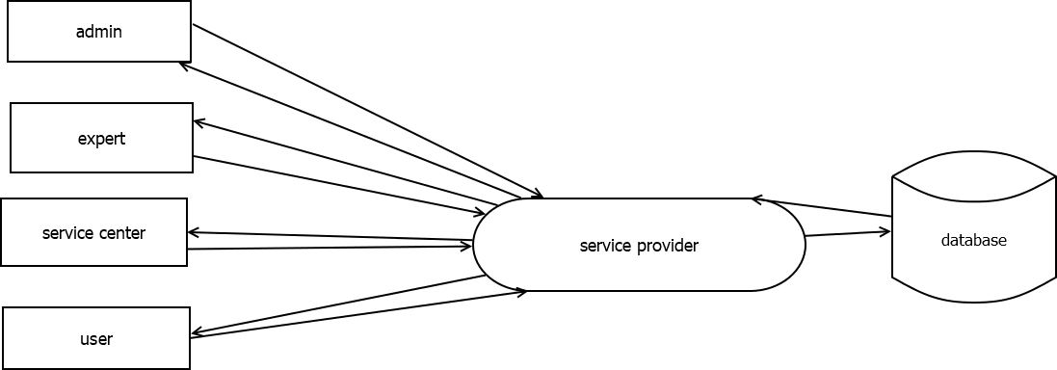

**1.1**

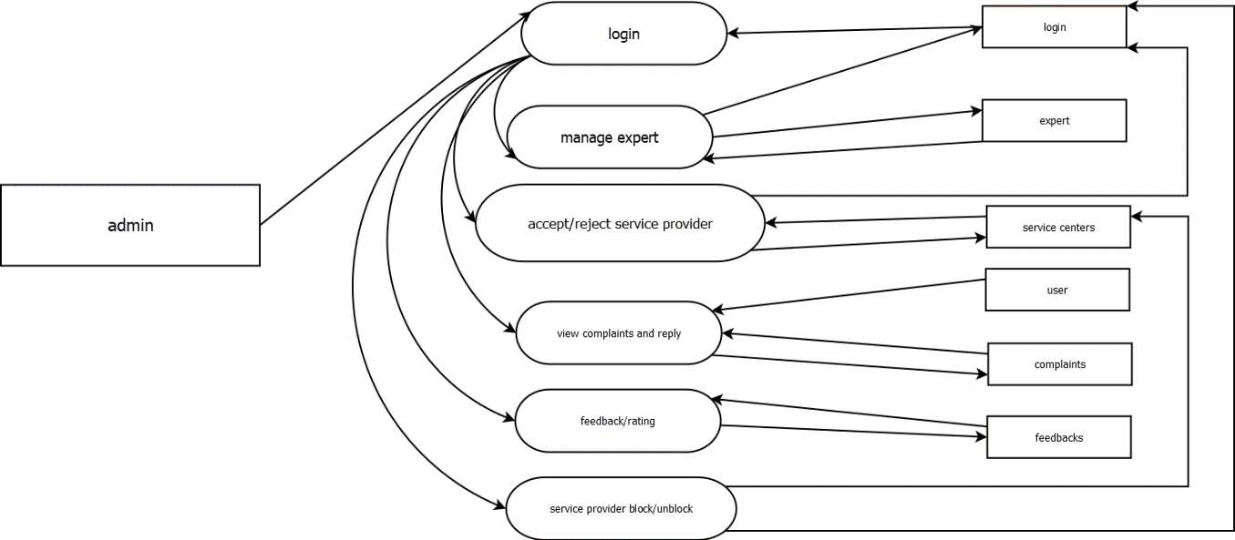

### 1.2

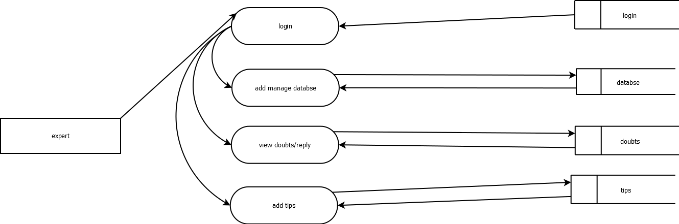

**1.3**

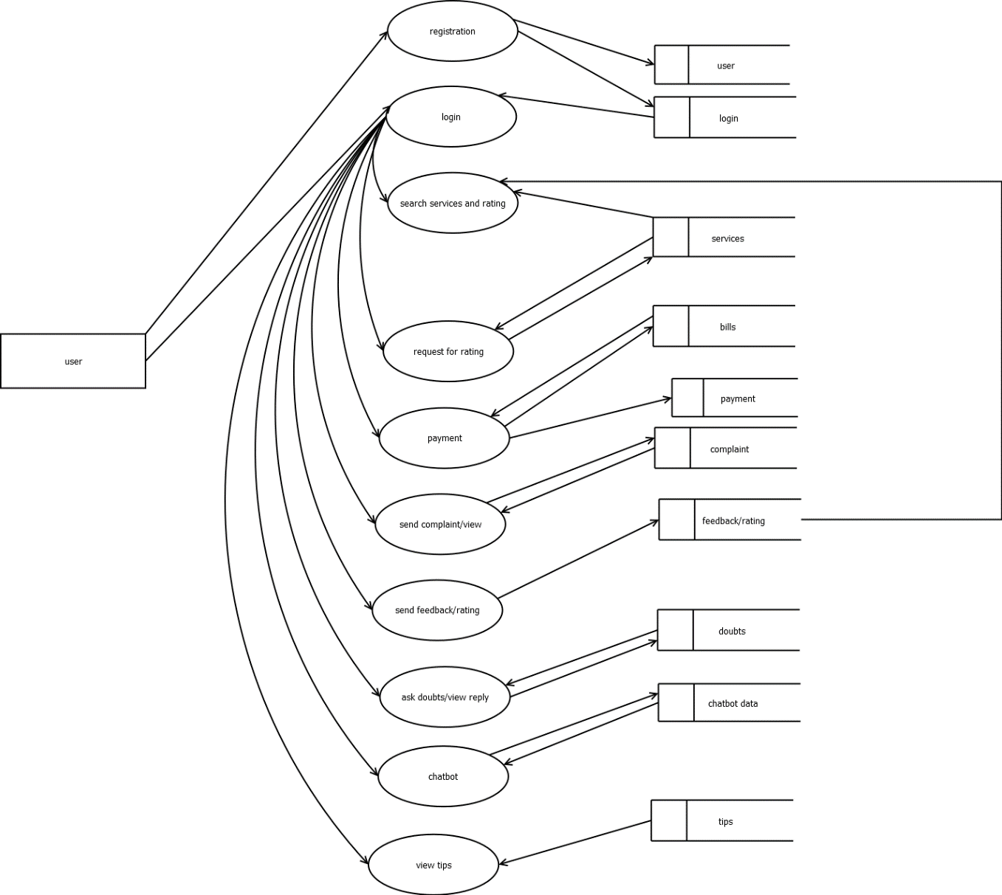

## DATABASE DESIGN

Database design is the process of producing a detailed data model of a database, This logical data model contains all the needed logical and physical design choices and physical storage parameters needed to generate a design in a data definition language, which can then be used to create a database. The term database design can be used to describe many different parts of the design of an overall database system. Principally, and most correctly, it can be thought of as the logical design of the base data structures used to store the data. In the relational model these are the tables and views. In an object database the entities and relationships map directly to object classes and named relationships. However, the term database design could also be used to apply to the overall process of designing, not

just the base data structures, but also the forms and queries used as part of the overall

database application within the database management system. The process of doing database design generally consists of a number of steps which will be carried out by the database designer.

Usually, the designer must:

*Determine the relationships between the different data elements.

*Superimpose a logical structure upon the data based on these relationships.

The Social distance mobile application uses project as its database for storing all the data in tables for data processing.

## TABLE DESIGN

Bill Table

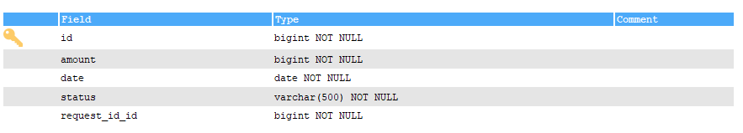

Chatbot

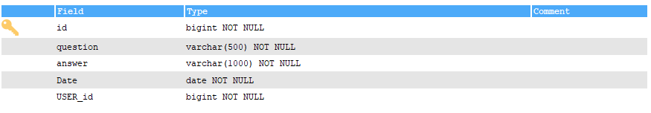

Complaint Table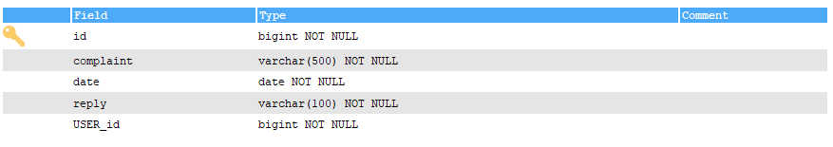

Database Table

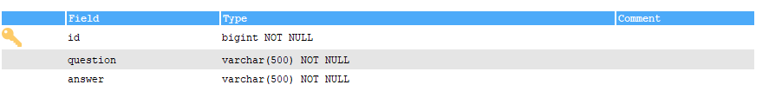

Doubts Table

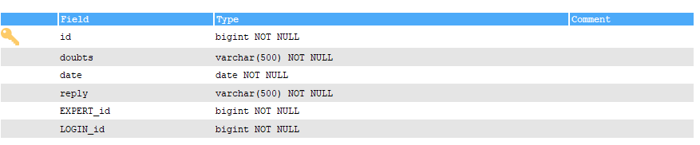

Feedback Table

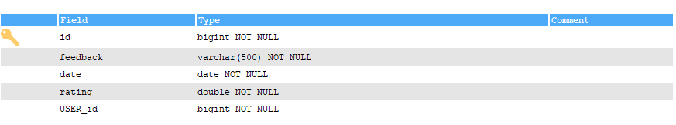

Expert Table

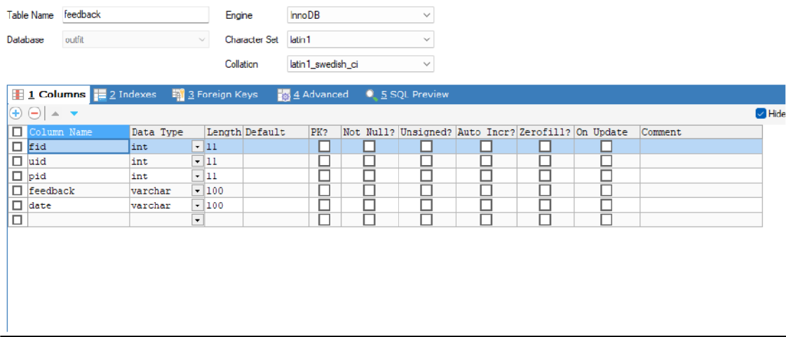

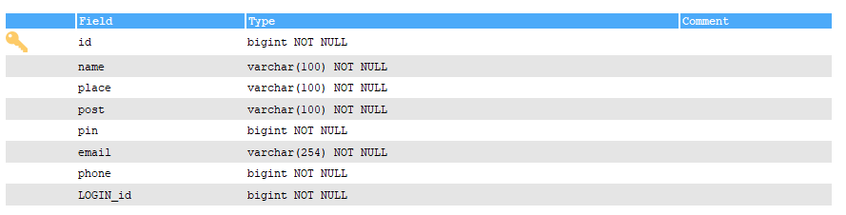

Login

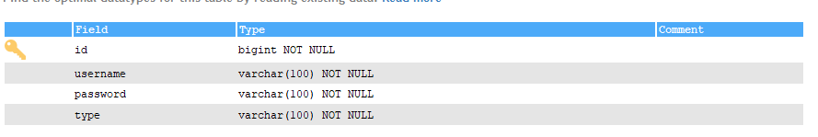

Payment Table

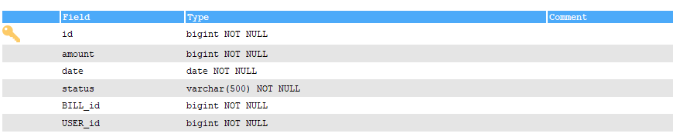

Service Center Table

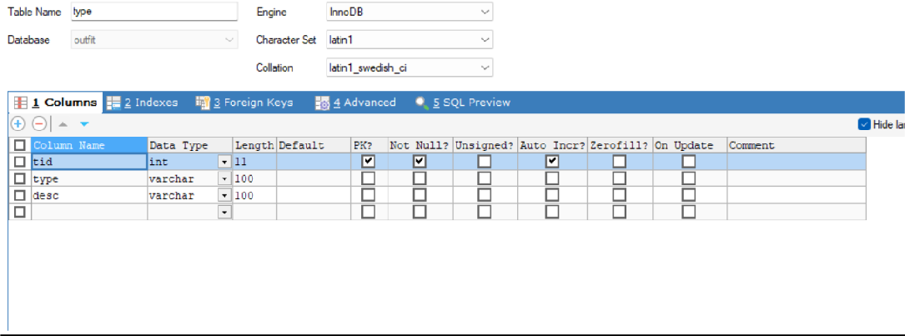

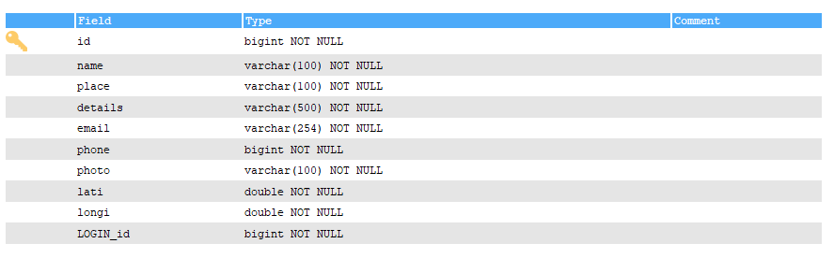

Service Request Table

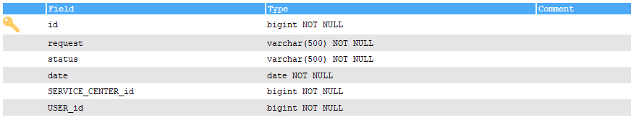

Services Table

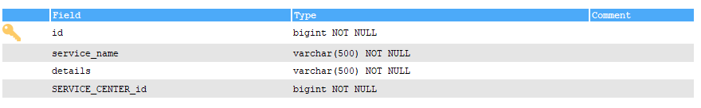

Tips Table

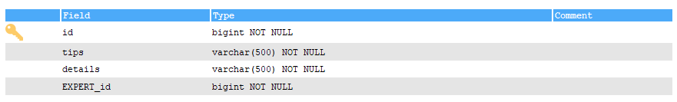

User Table

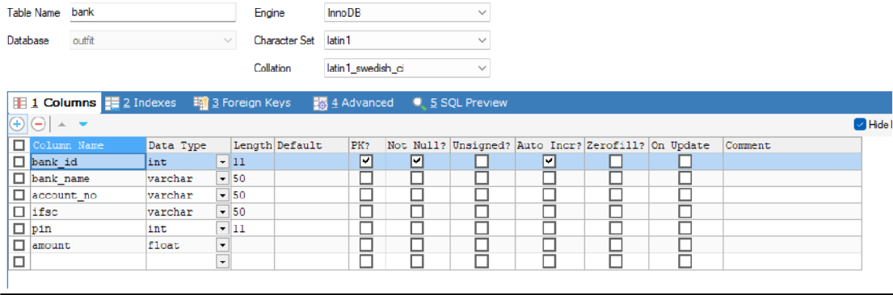

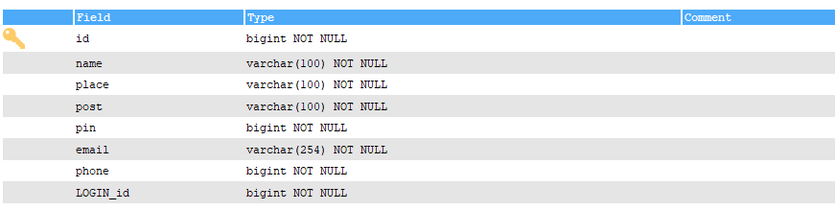

## INPUT DESIGN

Input design is the process of converting a user -oriented description of the inputs to a computer-based business system into a programmer -oriented specification. The goal of designing input data is to make data entry as easy, logical, and free from errors as possible. Input design is a part of the overall system design, which carefully requires attention. If the data going into the system is incorrect, then the processing and output will magnify these errors.

### The proposed system satisfies the following input design objectives:

*A cost-effective method of input

*The highest possible level of accuracy

*The input is acceptable to and understood by the user staff.

### Input Objectives are:

*Controlling the amount of input: Wherever user input is required, the number of keystrokes is by giving possible input Values as default that in that area. The viewer can select the answer in single click. The amount of information entered by the viewer using the keyboard is reduced to the maximum and the software is made very user friendly.

*Avoiding Delay: A processing delay resulting from data preparation or data entry operations is called a bottleneck. Such bottleneck are avoided to maximum. The only time viewer has to wait is when the file is uploaded or downloaded. Progress bar or progress meters are displayed to keep the user waiting and to show the speed and amount of download.

*Avoiding Errors in Data: The rate at which errors occur depends on the quantity of data. Here the quantity of data is reduced to the lowest, and a text file is easily manageable.

*Avoiding Extra Steps: The viewer can quit at any point of time. Even at the time of upload of download the viewer quit. The viewer need not wait for any specific event to happen for quitting the process.

*Keeping the process Simple: This implies that the system has all the measure to keep the error out even if the user is giving wrong data. It handles the situation with grace and doesn't create much hype about the situation to the user.

Several activities done in the input stages are:

**\*Data recording:** collection of data at its source.

**\*Data transcription:** transcription data to an input form.

**\*Data conversion:** conversion of the input data to a computer acceptable medium.

**\*Data verification:** checking the conversion.

**\*Data control:** checking the accuracy and controlling the flow of the data to the computer.

**\*Data transmission:** transmitting or transporting, the data to the computer.

**\*Data validation & correction:** checking & correcting the errors the input data by program when it enters the computer system.

## OUT DESIGN

The output from an information system should accomplish one or more of the following objectives:

*Convey information about past activities, current status or projections in future.

*Signal important events, opportunities, problems or warnings.

*Trigger an action.

*Confirm the action.

### Output Types:

*External Outputs, whose destination is outside the organization and is the main image of the organization.

*Internal Outputs, whose destination is within the organization und which require careful design because it is user's main interface with the computer.

*Operational Outputs, whose use is purely within the computer departments.

*Interactive outputs, which involve the user in communicating directly with the computer.

*Turn round Outputs, i.e.; reentrant documents, to which data will be added before they are returned to the computer for further processing.

# SYSTEM DEVELOPMENT

## FEATURES OF FRONT END AND BACK END

A Online servicing application typically consists of both a front-end and a back-end component. The front-end is the part of the application that the user interacts with, while the back-end is responsible for processing the user's requests and returning the appropriate response.

### Front-end features:

*User interface: The front-end of the application is responsible for presenting the user interface that the user interacts with. This might include features like selecting different types of services, sending a request etc.

*Responsive design: With the increasing number of devices with different screen sizes, a responsive design is necessary for the service application to adjust and display the content appropriately.

*User authentication: A Online service application may require users to create an account or log in with their social media accounts to search for centers or view their previous orders.

*Real-time updates: Users want to see the changes they make in real-time, hence the application must be able to display and update the requests preview as the user makes changes.

### Back-end features:

*Database management: The back-end of the application must store user information, such as account details, orders, and designs. It must also be able to retrieve that information when required.

*Integration with payment gateways: The back-end of the application must be able to process payment transactions when a user places an order.

*Security: To keep user data safe, the back-end must implement security measures to protect against attacks such as cross-site scripting (XSS), SQL injection, and unauthorized access.

*Scalability: As the user base and the volume of orders grow, the back-end must be able to scale accordingly to handle the increased load.

### PyCharm IDE

PyCharm is one of the most widely used IDES for Python programming language. At present, the Python IDE is being used by large enterprises like Twitter, Pinterest, HP, Symantec and Group on.

JetBrains has developed PyCharm as a cross-platform IDE for Python. In addition to supporting versions 2.x and 3.x of Python, PyCharm is also compatible with Windows, Linux, and macOS. At the same time, the tools and features provided by PyCharm help programmers to write a variety of software application in Python quickly and efficiently. The developers can even customize the PyCharm UI according to their specific needs and preferences. Also, they can extend the IDE by choosing from over 50 plug-ins to meet complex project requirements.

Overview of Important Features and Tools Provided by PyCharm

#### Code Editor

The intelligent code editor provided by PyCharm enables programmers to write high quality Python code. The editor enables programmers to read code easily through colour schemes, insert indents on new lines automatically, pick the appropriate coding style, and avail context-aware code completion suggestions. At the same time, the programmers can also use the editor to expand a code block to an expression or logical block, avail code snippets, format the code base, identify errors and misspellings, detect duplicate code, and auto-generate code. Also, the editor makes it easier for developers to analyse the code and identify the errors while writing code.

#### Code Navigation

The smart code navigation options provided by PyCharm help programmers to edit and improve code without putting extra time and effort. The IDE makes it easier for programmers to go to a class, file and symbols, along with the go to declarations invoked from a reference. The user can even find an item in the source code, code snippet, UI element, Of user action almost immediately. They can further locate usage of various symbols and set bookmarks in the code. At the same time, the developers can even take advantage of the code navigation feature to scrutinize the code thoroughly in the lens mode.

#### Refactoring

PyCharm makes it easier for developers to implement both local and global changes quickly and efficiently. developers can even take advantage of the refactoring options provided by the while writing plain Python code and working with Python frameworks, they can avail the rename and move refactoring for files, classes, functions, methods, properties & parameters, and local global variables. Likewise, they can improve code quality by extracting variables. fields, constants. and parameters, Also, PyCharm allows programmers to break up longer classes and methods through extract method.

#### Support for Popular Web Technologies

PyCharm makes it easier for programmers to write various web applications in Python supporting used web technologies like HTML, CSS, Javascript and CoffeeScript. The web developers can use the live editing preview option provided by the IDE to view a single web page simultaneously in the editor and browser. At the same time, the live edit feature provided by the (IDE enables programmers to see the changes made to the code instantaneously on a web browser. PyCharm further allows developers to avail a JavaScript debugger as well as CoffeeScript and TypeScript editors. It even simplifies isomorphic web application development by supporting both AngularJS and NodeJS.

#### Support for Popular Python Web Frameworks

In addition to supporting commonly used web technologies, PyCharm also provides first class support for a robust Python web framework like Django. The developers can use the IDE to avail code completion suggestions for Django tags, filters, parameters, and template variables. Also, they can gather additional information about tags and filters by referring to the quick documentation. The Python IDE even helps web developers to debug Django templates, format the code, verify the code, and manage .py consoles. At the same time, PyCharm also supports widely used Python web frameworks like Pyramid and Web2Py. It provides code completion and navigation options specific to Pyramid Likewise, it allows web developers to avail code completion and navigation options while working with Web2Py.

#### Support for Python Scientific Libraries

PyCharm further helps programmers to use Python more efficiently in big data and data science projects. It supports some of the widely used scientific libraries for Python- NumPy, Anaconda and Metplotlib. The developers can work efficiently with these scientific libraries by availing the interactive graphs, deep code insight, and array viewers provided by the IDE. They can even run the REPL Python console provided by PyCharm to avail robust features like on-the-fly syntax check and code inspection. At the same time, the programmers can also integrate the IDE seamlessly with I Python Notebook to create innovative solutions Without putting extra time and effort.

#### Database Tools

In addition to supporting various Python libraries and frameworks, PyCharm allows developers to work with a number of relational databases including Oracle, SQL Server, MySQL and PostgreSQL. The developers can further use the IDE to run queries, edit SQL code, browse data, alter table data. and alter/analyse schemas. PyCharm further SQL Alchemy library and inject SQL code into code written in various programming languages.

The professional edition of the IDE further makes it easier for developers to handle large volumes of data efficiently through data grids.

#### Visual Debugger

The visual debugger provided by the IDE helps programmers to debug Python, JavaScript. and Django code. The developers can use the inline debugger to see live debugging data directly on the editor Likewise, they can debug multiple Python processes simultaneously and step through the code bypassing libraries. PyCharm further creates reusable and customizable Configuration for each test script or debugger execution. The users even have option to facilitate remote debugging by integrating the visual debugger with remote interpreter.

#### Built-in Terminal

PyCharm comes with local terminals for Windows, Linux, and macOS. The built-in terminal enables programmers to continue coding and testing without leaving the IDE. Also, the programmers can use the IDE to run Python files and configure custom Python environments according to precise project requirements. At the same time, they can run interactive Python or Django consoled directly in the IDE. The console provides useful features like code completion, automatic braces matching, and dynamic syntax change. The programmers even have option to integrate the console with both local and remote interpreters.

#### Support for Major Version Control Systems

PyCharm allows developers to work with widely used version control systems like Git, Mercurial, Perforce and SVN. It even performs complex tasks like adding, removing, and deleting files automatically. The developers even have option to avail a number of features provided by the IDE regardless of their choice of version control system — grouping individual changes into multiple change lists, setting aside the changes to be restored, monitor changes made to the code repository by various users, and check the changes made to the code before being integrated into the local copy.

#### Software Testing

Like other IDES, PyCharm also comes with features and tools to simplify Python application testing. It allows developers to perform unit testing through popular Python

testing frameworks like Nose, Attest and Doctests. The testers even have option to run individual or multiple test files and test Classes. They further the IDE With Coverage.py to measure code coverage while testing the applications. While testing multi-threaded applications, the testers can use the thread concurrency visualization option provided by the IDE to control the application fully and efficiently. At the same time, PyCharm enables users to deliver high quality software by implementing behaviour-driven development (BDD).

#### Remote Development Capabilities

PyCharm allows developers to connect with various machines and build software applications remotely. The programmers can avail the built*in SSH console by the IDE to connect to machines and perform various development tasks remotely through SSH. They can even run, debug, and profile the Python applications in a remote environment by replacing the local Interpreter with a remote interpreter. Also, PyCharm enables programmers to create repr0ducible development environments through a robust tool like Vagrant and simplify distributed application development through Docker. The users even have option to integrate PyCharm seamlessly with issue tracking systems. On the whole, PyCharm is one of the most Popular IDES for Python. The Python programmers can use PyCharm as licensed software. However, JetBrains allows developers to choose from three distinct editions of the IDE-Community, professional and educational. The developers can always curtail software development cost by opting for the community edition of PyCharm. The community edition still lacks some of the advanced features provided by the professional editions. JetBrains has been updating both editions of the Python IDE to make programmers more productive and simplify custom software development. For instance, the professional edition of PyCharm 2017.3 makes it easier for developers to test functionality of APIs by providing a built-in REST client. Likewise, it accelerates web application development by allowing programmers to avail the new features provided by Django 2.0. Also, it allows developers to Visualize and analyse data more efficiently through a data science mode.

### ANDROID

Android is a mobile operating system developed by Google. It is used by several smartphones and tablets. Examples include the Sony Xperia, the Samsung Galaxy, and the Google Nexus One. The Android operating system (OS) is based on the Linux kernel.

#### Near Field Communication (NFC)

Most Android devices support NFC, which allows electronic devices to easily interact across short distances. The main aim here is to create a payment option that is simpler than carrying credit cards or cash, and while the market hasn't exploded as many experts had predicted, there may be an alternative in the works, in the form of Bluetooth Low Energy (BLE).

#### Alternate Keyboards

Android supports multiple keyboards and makes them easy to install; the Swift Key Skype, and 8pen apps all offer ways to quickly change up your keyboard style. Other mobile Operating systems either don’t permit extra keyboards at all, or the process to install and use.

#### Infrared Transmission

The Android operating system supports a built-in infrared transmitter, allowing you to use your phone or tablet as a remote control.

#### No-Touch Control

Using Android apps such as Wave Control, users can control their phones touch-free, using only gestures. Have messy hands but need to turn off your screen or change a song? Simple. This could prove especially useful if you're driving, so you can keep both eyes on the road.

#### Automation

The Tasker app lets you not only control app permissions but also automate t hem. Do you only want your location services to be active during the day? Want to create a customized

way to start your music for example, with a voice command and at a certain Volume? Tasker can help.

#### Wireless App Downloads

Accessing app stores on any mobile device can be frustrating, but iOS makes it a little more difficult download an app on your computer, and it won't sync to your moblie device until you plug in and access iTunes. Using the Android Market or third-party options Iike AppBrain, meanwhile, let you download apps on your PC and then automatically sync them your Droid, no plugging required.

#### Storage and Battery Swap

Android phones also have unique hardware capabilities. Google's OS makes it possible to remove and upgrade your battery or to replace one that no longer holds a charge. In addition, Android phones come with SD card slots for expandable storage.

#### Custom Home Screens

While it's possible to hack certain phones to customize the home screen, Android comes with this capability from the get-go. Download a third-party launcher like Nova, Apex or Slide and you can add gestures, new shortcuts, or even performance enhancements for older-model devices.

#### Widgets

Apps are versatile, but sometimes you want information at a glance instead of having to open an app and wait for it to load. Android widgets let you display just about any feature you choose, right on the home screen including weather apps, music widgets, or productivity tools that helpfully remind you of upcoming meetings or approaching deadlines.

#### Custom ROMs

This is a big one. Because the Android operating system is open source, developers can tweak the current. OS and build their own versions, which users can download and install

in place of the stock OS. Some are filled with features, while others change the look and feel of a device. Chances are if there's a feature you want, someone has already built a custom ROM for it.

### MySQL

MySQL, the most popular Open-Source SQL database management system, is developed. distributed, and supported by Oracle Corporation.

#### MySQL is a database management system.

A database is a structured collection of data. It may be anything from a simple shopping list to a picture gallery or the vast amounts of information in a corporate network. To add, access, and process data stored in a computer database, you need a database management system such as MySQL Server. Since computers ate very good at handling large amounts of data, database management systems play a central role in computing, as standalone utilities, or as parts of other applications.

#### MySQL databases are relational.

A relational database stores data in separate tables rather than putting all the data in one big Storeroom. The database structures are organized into physical files optimized for speed. The logical model, with objects such as databases, tables, views, rows, and columns, offers a flexible programming environment. You set up rules governing the relationships between different data fields, such as one-to-one, one-to-many, unique, required or optional, and “pointers” between different tables. The database enforces these rules, so that with a well-designed database, your application never sees inconsistent , duplicate , orphan, out-of-date, or missing data.

The SQL part of "MySQL" stands for "structured Query Language". SQL is the most common standardized language used to access databases. Depending on your programming environment, you might enter SQL directly (for example, to generate reports), embed SQL statements into code written in another language, or use a language- specific API that hides the SQL syntax. SQL is defined by the ANSI/ISO SQL Standard. The SQL standard has been evolving since 1986 and several versions exist.

#### MySQL software is Open Source.

Open Source means that it is possible for anyone to use and modify the software. Anybody can download the MySQL software from the Internet and use it without paying anything. If you wish, you may study the source code and change it to suit your needs. The MySQL software uses the GPL (GNU General Public License), to define what you may and may not do with the software in different situations.

#### MYSQL Database Server is very fast, reliable, scalable, and easy to use.

MySQL Server can run comfortably on a desktop or laptop, alongside your other applications, web servers, and so on, requiring little or no attention. If you dedicate an entire machine to MySQL, you can adjust the settings to take advantage of all the memory, CPU power, and I/O capacity available. MySQL can also scale up to clusters of machines, network together.

### SQLyog

SQLyog provides you with powerful means to manage your MySQL databases.

* Runs on a!! Windows version from Win XP to Win 8.x (desktop systems) as well as "Windows Server" systems of same generations (Windows Server 2003 and higher).
* MySQL 5.x compatible
* Create/Drop/Alter Tables, Stored Procedures, Functions, Views, Triggers and Events.
* HTTP and SSH Tunnelling - smartly manage your MySQL server even if the MySQL port is blocked or remote access to MySQL is disallowed!
* Protect your data with S.SL encryption
* Smart Auto Complete.
* Formats SQL statements.
* Proactive Query Profiler.
* Favorite Manager to neatly organize your favorite SQL statements.
* Very fast retrieval of data.
* Advanced GUI Query Builder. Supports JOINs, aggregate as well as 'common' functions, sorting (ORDER BY) and filtering (WHERE and HAVING) and ALIAS.
* SQLyog Import External Data wizard - use the GUI or specify a query .
* Schema and Data synchronization tools.
* Powerful compressed Scheduled Backup with email notification.
* Schedule various jobs.

### SQL Commands

SQL commands are instructions, coded into SQL statements, which are used to communicate with the database to perform specific tasks, work, functions and queries with data. SQL commands can be used not only for searching the database but also to perform various other functions like, for example, you can create tables, add data to tables, or modify data, drop the table, set permissions for users. SQL commands are grouped into four major categories depending on their functionality:

#### Data Definition Language (DDL)

These SQL commands are used for creating, modifying, and dropping the structure of database objects. The commands are CREATE, ALTER, DROP, RENAME, and TRUNCATE.

#### Data Manipulation Language (DML)

These SQL commands are used for storing, retrieving, modifying, and deleting data. These Data Manipulation Language commands are: SELECT, INSERT, UPDATE, and DELETE.

#### Transaction Control Language (TCL)

These SQL commands are used for managing changes affecting the data. These commands are COMMIT, ROLLBACK, and SAVEPOINT.

#### Data Control Language (DCL)

These SQL commands are used for providing security to database objects. These commands are GRANT and REVOKE.

## PROJECT PLANNING

For the successful completion of every project there must be detailed scheduling. The software development has different participating steps. First of all, I done the requirement analysis phase. For this I visit different sites that offer resume writing helps, visits different business websites, and I discuss with my friends and project guide.

After collecting the requirements, a detailed study of preliminary investigation is done. It includes six major questions:

1. What is being done?
2. How it is being done?
3. Done a problem exist?
4. If a problem exists how severe it is?
5. How frequently does it occur?
6. What is main reason for that problem?

## 5.2 PROJECT SCHEDULING

To create a project schedule for an Online Servicing app, you would need to break down the project into smaller tasks, estimate the time required to complete each task, and then organize these tasks into a timeline.

### Research and Planning

Conduct market research and analysis of competition (1 week) Define project goals and objectives (2 days)

Create a project plan and timeline (1 day)

### Design and Development

Create wireframes and mockups (2 weeks) Develop frontend (4 weeks)

Develop backend (4 weeks)

Integrate frontend and backend (1 week) Test and debug (2 weeks)

### Content Creation

Create product images (2 weeks) Create product descriptions (1 week) **Marketing and Launch** Develop marketing strategy (2 weeks)

Create promotional materials (2 weeks) Launch the app (1 week)

# SYSTEM TESTING

## TYPES OF TESTING

#### White-box Testing Black-box Testing Condition Testing Loop Testing

**Unit Testing Integration Testing Output Testing**

**User Acceptance Testing**

**White-box Testing**

Tests are performed to ensure that all internal operations of the software are performed according to the specifications of the client. This is called White box testing. White-box testing (also known as clear box testing, glass box testing, transparent box testing, and structural testing) is a method of testing software that tests internal structures or workings of an application, as opposed to its functionality (i.e. black-box testing). In white-box testing an internal perspective of the system, as well as programming skills, are used to design test cases.

White-box testing can be applied at the unit, integration and system levels of the software testing process. Although traditional testers tended to think of white-box testing as being done at the unit level, it is used for integration and system testing more frequently today. It can test paths within a unit, paths between units during integration, and between subsystems during a system– level test. Though this method of test design can uncover many errors or problems, it has the potential to miss unimplemented parts of the specification or missing requirements. The details entered by the administrator are saved and stored in the database, and testing is done to verify whether the control of each form or action is working in the exact way.

### Black-box Testing

Tests are performed to ensure that each function is working properly. This is referred to as Black-box testing. Black-box testing is a method of software testing that examines the functionality of an application (e.g., what the software does) without peering into its internal structures or workings. This method of test can be applied to virtually every level of software testing: unit, integration, system and acceptance. It typically comprises most if not all higher-level testing, but can also dominate unit testing as well. Test cases are built around specifications and requirements, i.e., what the application is supposed to do. Test cases are generally derived from external descriptions of the software, including specifications, requirements and design parameters. Although the tests used are primarily functional in nature, non-functional tests may also be used. The test designer selects both valid and invalid inputs and determines the correct output without any knowledge of the test object's internal structure. Testing is conducted in the system so that the functions namely Login, sending requests, searching the nearest donor, getting routes to the nearest blood banks etc... are done properly.

### Condition Testing

Test cases are derived to determine whether the logic conditions and decision statements are free from errors. Condition testing strategy is used to check if the operators used are correct and to verify conditions such as if an error message is displayed if a non-registered user is signed in to the app, or a user is registered without providing his body mass index value.

### Loop Testing

This testing is used to check the variety of loops present in programming. The working of the loops such as while, for and do while are checked for its proper execution. The statements inside the loop body are executed line by line for every condition that satisfies the loop.

### Unit Testing

Unit testing focused verification efforts on the smallest unit of software design, the module. This is also known as “module testing”. The modules are tested separately. This testing is carried out during programming stage itself. In this testing step each module is found to be working satisfactorily as regard to the expected output from the module.

Project Aspect: User interfaces are tested for data acceptance. Each of the modules such as Login, item add modules etc. are tested individually and found error free.

### Integration Testing

Data can be lost across the interfaces; one module can have an adverse effect on the other; sub functions when combined, may not produce the desired major functions. The integration testing is a systematic testing for constructing the programs’ structure, while at the same time conducting tests to uncover errors associated within the interface. The objective is to take unit tested modules and build a program structure. All the modules are combines and tested as a whole. Here correction is difficult because the vast expenses of the entire program complicate the isolation of causes. Thus, in the integration testing step, all the errors uncovered are corrected for the next testing steps.

Project aspect: Using integrated test plans prepared in the design phase of the system developed as a guide, the integration test was carried out. The modules are integrated and tested and all the errors found in the system were corrected for the next testing steps.

### Output Testing

After performing the validation testing, the next step is output testing of the proposed system since no system could be useful if it does not produce the required output in specific format. Asking the users about the format required by them tests the outputs generated or displayed by the system under consideration. The output format of the screen is found to be correct as the format was designed in the system design phase according to the user

needs. For the hard copy also, output comes out as the specified requirements by the user. Hence output testing does not result in any correction in the system. Various reports are generated in graphical output format and being pictorial representation, it is found more convenient to understand by the users of the system.

### User Acceptance Testing

User acceptance testing of a system is the key factor for the success of any system. The system under consideration is tested for user acceptance by constantly keeping in touch with the prospective system users at the time of developing and making changes wherever required. This is done with regard to the following points.

## TESTING

### Testing Objectives

Testing is an important step in the software engineering process that could view rather than constructive. Testing is the process of executing a program with the intent of finding an error. a good test is that has probability to find an as yet undiscovered error.

*A good case is one that has a high probability of finding an unpredictable error.

*A successful case is one that has a high probability of finding an unpredictable error.

*A good test case is one that provides solution to that unpredictable error.

*A test plan entailed the following activities. We prepare list plan.

*We specified condition for users’ acceptance testing.

*We prepared list data for program testing.

*Also, we prepared list data transaction plan testing.

*Then we planned user training.

*Our programs were compiled and assembled.

*Job performance aids were prepared.

### Need For Testing

Software testing is a critical element of software quality assurance and represents the ultimate review of specification, design and coding. testing includes the verification of the basic logic of each program and verifies that the entire system works properly. Testing the individual program involves an attempt to be sure of the most likely possible. Test case design focuses on asset of technique for the creation test the cases that meet over all testing objectives.

## TESTING STRATEGY

Software testing determines the correctness, completeness, and quality of software being developed. Validation refers to the process of checking that the developed software meets the requirements specified by the user. The activities involved in the testing phase basically evaluate the capability of that system meets its requirements. The main objective of software testing is to detect errors in the software. Errors occur if some part of the developed system is found to be incorrect, incomplete or inconsistent. Test techniques include, but are not limited to, the process of executing a program or application with the intent of finding software bugs (errors or other defects). It involves the execution of a software component or system to evaluate one or more properties of interest. In general, these properties indicate the extent to which the component or system under test:

*Meets the requirements that guided its design and development,

*Responds correctly to all kinds of inputs,

*Performs its functions within an acceptable time,

*Is sufficiently usable,

*Can be installed and run in its intended environments, and achieves the general result its stake holder’s desire.

As the number of possible tests for even simple software components is practically infinite, all software testing uses some strategy to select tests that are feasible for the available time and resources. As a result, software testing typically (but not exclusively) attempts to execute a program or application with the intent of finding software bugs (errors or other defects). Software testing can provide objective, independent information about the quality of software and risk of its failure to users and/or sponsors. Software testing can be conducted as soon as executable software (even if partially complete) exists. The overall approach to software development often determines when and how testing is conducted. For example, in a phased process, most testing occurs after system requirements have been defined and then implemented in testable programs. In contrast, under an Agile approach, requirements, programming, and testing are often done concurrently.

### TEST RESULTS

Test results emphasize how the actual results differed from the expected results. This suggests the need for re-testing, and to discover the source of differences. The test phase of systems development process involves the defining of the criteria by which the system will be tested and measuring the criteria against the acceptable failure rate. Individual modules are tested during the development itself. Errors detected are corrected and re- tested, and the project leader has verified the compliance. Each input, output and processes are tested to verify that it performs as specified in the design. The units in the system are re-compiled and errors found are corrected as

indicated by the compiler. The tests are repeated until all known errors are eliminated and the program matched the design specifications. Separate tests are performed to ensure that program units are properly interfaced with each other to form a complete system.

# SYSTEM IMPLEMENTATION

## SYSTEM IMPLEMENTATION

**User Interface:** The user interface of your app should be user-friendly and easy to navigate. It should allow users to browse and select Service centers, services , and other options easily.

**Market Research:** Conduct market research to understand the demand for electronics servicing in your target market. Identify competitors, their strengths and weaknesses, and opportunities for differentiation

**User Support:** Offer customer support channels (e.g., live chat, email, phone support) to assist users with service requests, troubleshooting, and any other issues they encounter while using the app.

**Payment Gateway:** You will need to integrate a payment gateway to allow users to pay for the Services. This should include support for multiple payment methods, such as credit cards, PayPal, and other popular payment options.

**Marketing and Promotion:** Promote the app through digital marketing channels, social media, and partnerships with electronics retailers or manufacturers. Highlight key features, benefits, and customer testimonials to attract users and build trust.

**Maintenance and Updates:** Regularly monitor the app for bugs, performance issues, and security vulnerabilities. Provide updates and improvements based on user feedback and emerging technologies.

**Testing:** Conduct thorough testing to ensure the app functions correctly across different devices and platforms. Test usability, performance, security, and compatibility with various browsers or mobile devices.

**Analytics and Reporting:** You will need to collect data on user behavior, such as the most popular Center items and best service , to improve your app's performance and provide insights for marketing and promotional activities.

# MAINTENANCE AND SECURITY

## SYSTEM MAINTENANCE

**\*Regular updates:** Regular updates of the app's software, including bug fixes, security patches, and feature enhancements, should be performed to ensure that the app runs smoothly and securely.

**\*Server maintenance:** The app's server should be monitored and maintained to ensure that it is running smoothly and that users can access the app without any issues.

**\*Database optimization:** The app's database should be optimized to ensure that it is running efficiently and that data is being stored and retrieved quickly.

**\*Performance monitoring:** Regular monitoring of the app's performance should be performed to identify any issues and optimize the app's speed and responsiveness.

**\*User feedback analysis:** Feedback from users should be analyzed regularly to identify any issues or areas of improvement for the app.

**\*Security updates:** Regular security updates should be performed to ensure that the app is protected against any potential security threats.

**\*Backup and disaster recovery:** Regular backups of the app's data should be performed, and a disaster recovery plan should be in place in case of any unexpected events.

## SYSTEM SECURITY

System security is an essential aspect of an Online servicing app to protect the sensitive user data and maintain the trust of the users. Here are some measures that can be taken to ensure the security of an Online servicing app:

**\*Secure Authentication:** A strong authentication mechanism should be implemented to ensure that only authorized users can access the app. This

can include methods such as password-based authentication, biometric authentication, or multi-factor authentication.

**\*Data Encryption:** Sensitive user data such as login credentials, payment information, and personal information should be encrypted using strong encryption methods such as AES or RSA to prevent unauthorized access.

**\*Regular Security Audits:** Regular security audits should be conducted to identify and address any vulnerabilities in the app's code, database, or server.

**\*Use of SSL Certificates:** SSL certificates should be used to ensure secure communication between the app's server and the user's device, preventing any data interception or tampering.

**\*Firewall Protection:** A firewall should be implemented to protect the app's server from any unauthorized access or malicious attacks.

**\*Secure Data Storage:** Sensitive user data should be stored securely in encrypted databases or cloud storage services, protected by strict access controls.

**\*Penetration Testing:** Regular penetration testing should be performed to identify any vulnerabilities in the app's code or infrastructure that can be exploited by attackers.

By implementing these measures, the Online servicing app can be secured from potential threats, ensuring the safety and privacy of the users' data.

# CONCLUSSIONS

In conclusion, the development and implementation of an online servicing app for electronics offer significant opportunities to streamline and enhance the repair and maintenance experience for consumers and technicians alike. By leveraging modern technologies and user-centric design principles, such an app can revolutionize the way electronic devices are serviced and contribute to greater customer satisfaction and loyalty.

Users can easily request servicing for their electronics from the comfort of their homes, eliminating the need for in-person visits to repair shops or service centers.

Real-time updates on the status of repair requests provide users with visibility into the progress of their repairs, enhancing trust and confidence in the service.

Streamlined processes for service request handling, communication between users and technicians, and payment processing result in faster turnaround times and improved efficiency.

In summary, an online servicing app for electronics has the potential to transform the way electronic devices are serviced, offering unparalleled convenience, transparency, and efficiency to users while driving business growth and differentiation for service providers. By prioritizing user experience, reliability, and innovation, such an app can become an indispensable tool in the electronics repair industry, delivering value to both consumers and businesses alike.

# SCOPE FOR THE FUTURE ENHANCEMENT

The future scope for an online servicing app for electronics is promising, with several potential avenues for growth and innovation. Here are some key areas where the app could evolve and expand its offerings:

**\*** **Advanced Diagnostic Capabilities: I**ntegrate artificial intelligence (AI) and machine learning (ML) algorithms to enhance diagnostic capabilities. The app could analyze device data and user-reported issues to provide more accurate diagnostics and predictive maintenance recommendations.

**\*** **Augmented Reality (AR) Support**: Implement AR technology to assist users and technicians during troubleshooting and repair processes. AR overlays could provide step-by-step instructions, highlight components, and offer real-time guidance for disassembly and reassembly tasks.

**\*** **IoT Integration:** Integrate with Internet of Things (IoT) devices to enable remote monitoring and management of connected electronics. Users could receive alerts for potential issues, monitor device performance metrics, and even initiate self-repairs or firmware updates through the app.

**\*** **Community Engagement and Knowledge Sharing :** Foster a community-driven platform where users can share tips, troubleshoot issues together, and exchange insights and experiences. Implement features such as forums, user-generated tutorials, and peer-to-peer support networks to facilitate knowledge sharing and collaboration.

By embracing emerging technologies, embracing sustainability initiatives, and fostering community engagement, an online servicing app for electronics can continue to evolve and meet the evolving needs of users and the electronics industry in the years to come.

Top of Form

# BIBLIOGRAPHY

### BOOKS

1. W. Zhao, R. Chellappa, P.J. Phillips, and A. Rosenfeld, “Face Recognition: A Literature Survey,” ACM Computing Surveys, vol. 35, pp. 399-459, 2003.
2. Willian Jordon, “Python Django Web Development: The Ultimate Django web framework guide for Beginners”, Kindle Edition.
3. Zigurd Mednieks, “Programming Android: Java Programming For The New Generation Of Mobile Devices”, Second Edition.
4. Walter Shields, “SQL QuickStart Guide: The Simplified Beginner's Guide to Managing, Analyzing, and Manipulating Data With SQL”

### LINKS

1. https://stackoverflow.com/questions/25193275/run-code-after-rendering-django
2. https://developer.android.com/studio 3.https://docs.opencv.org/trunk/db/d28/tutorial_cascade_classifier.html

# 12.APPENDIX

**Sample input and Output**

**Screenshots ADMIN WEBSITE:** LOGIN

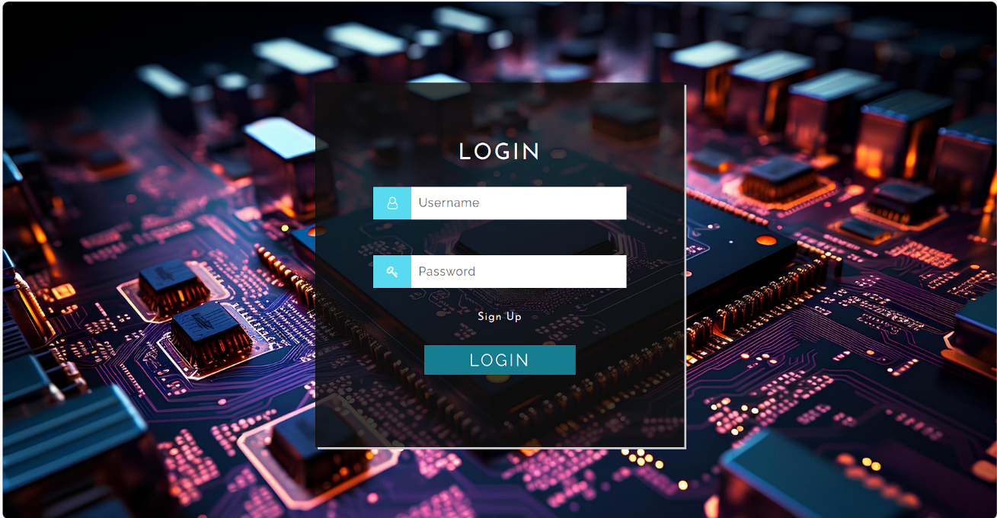

ADD AND MANAGE EXPERT

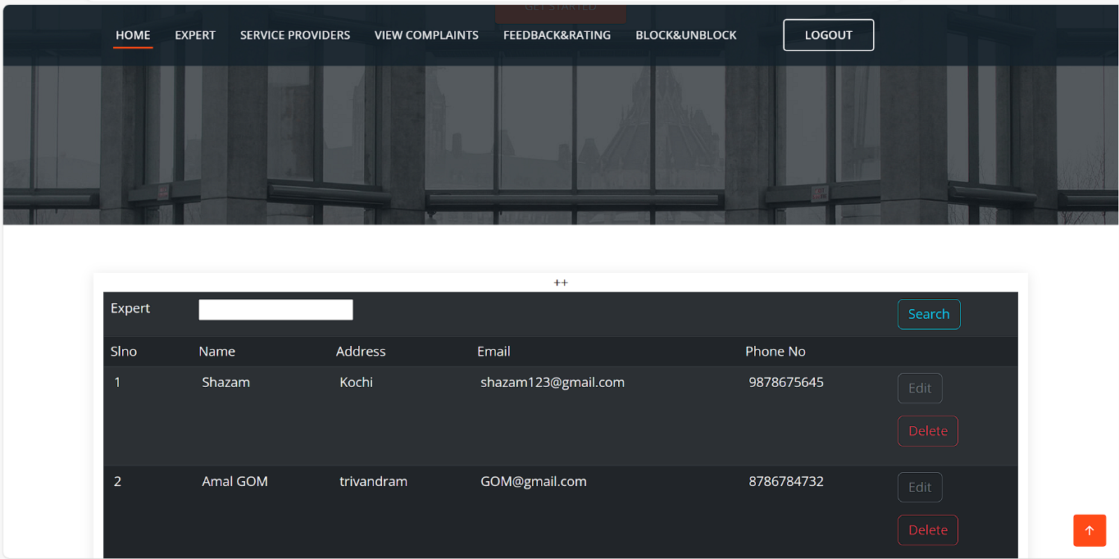

ACCEPT/REJECT SERVICE PROVIDER

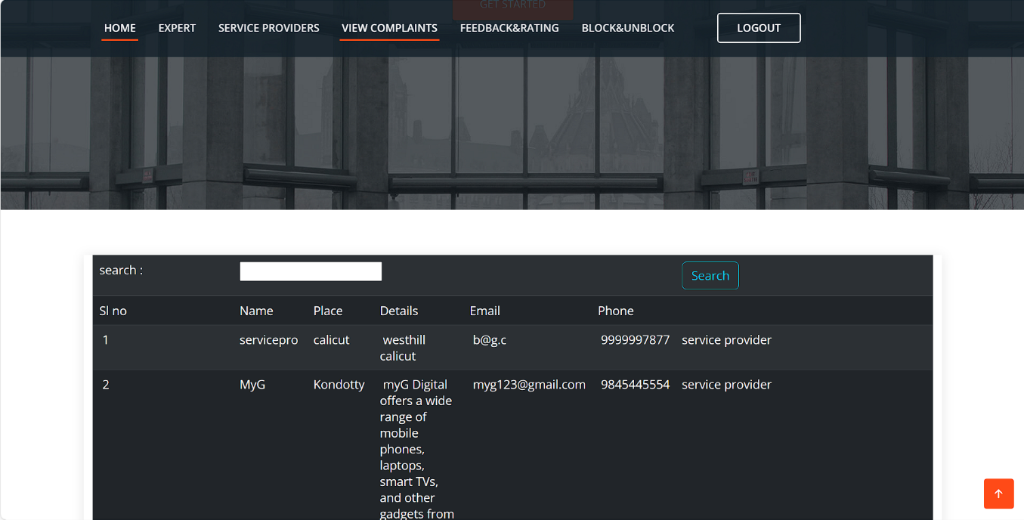

VIEW COMPLAINT AND REPLY

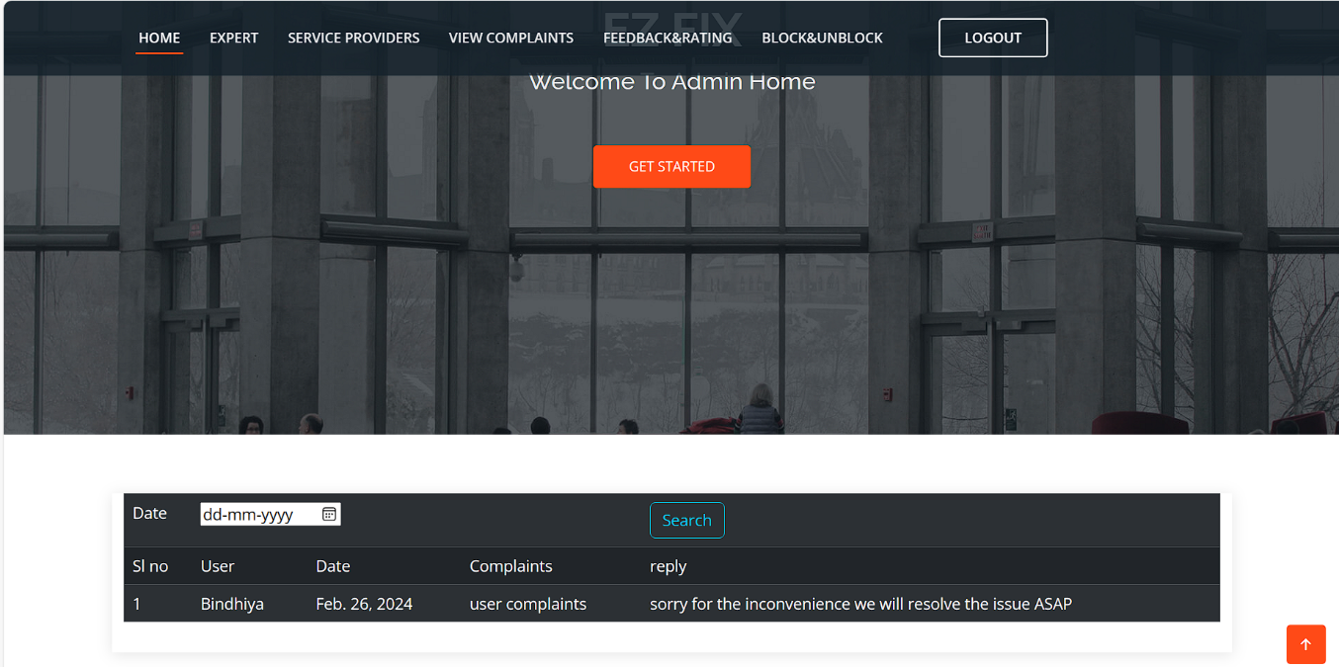

VIEW FEEDBACK AND RATING

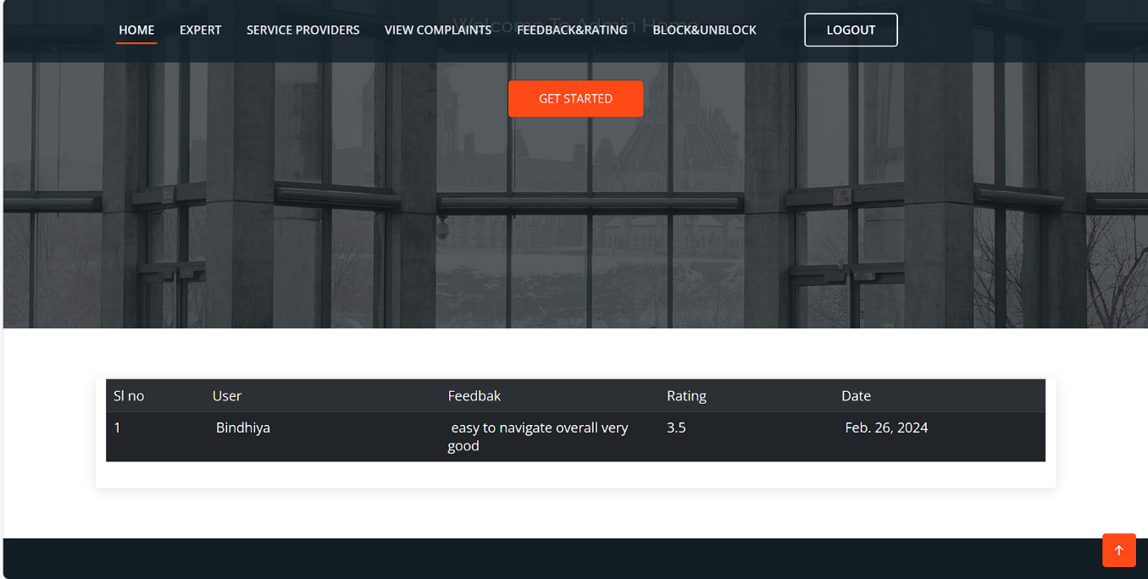

BLOCK OR UNBLOCK

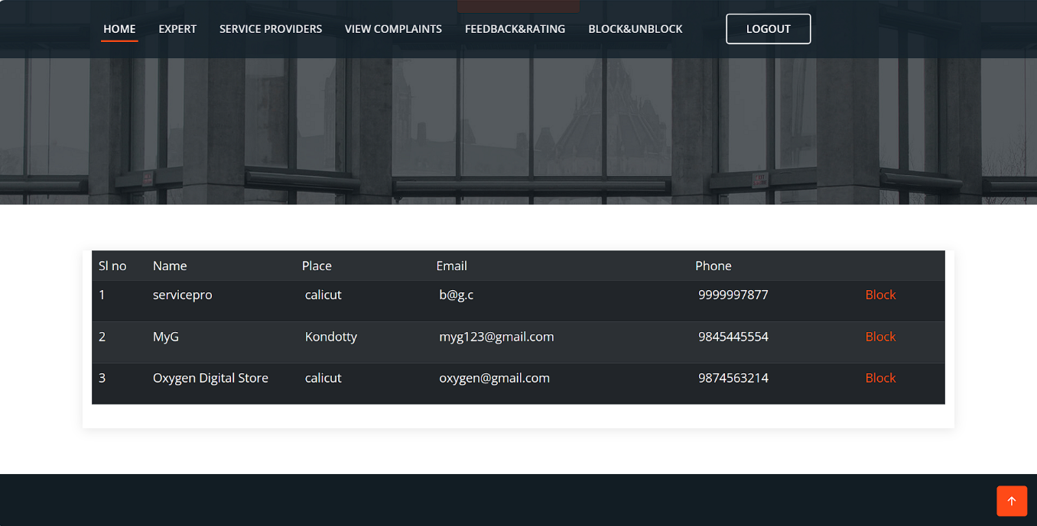

#### SERVICE CENTER WEBSITE:

REGISTRATION

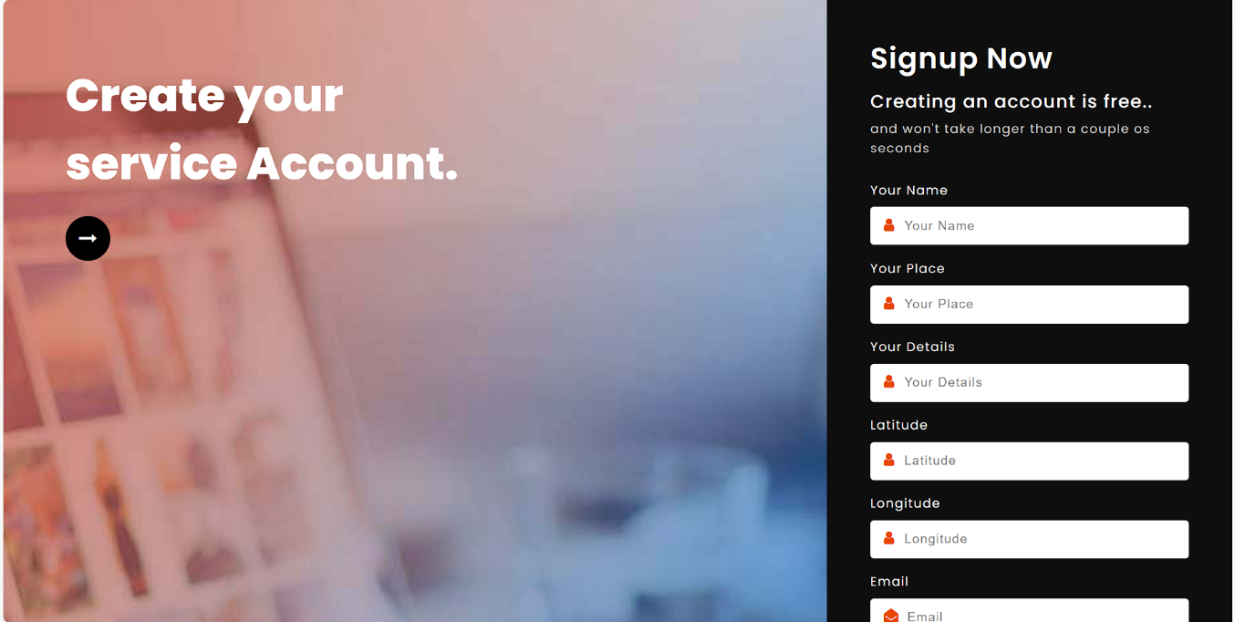

HOME

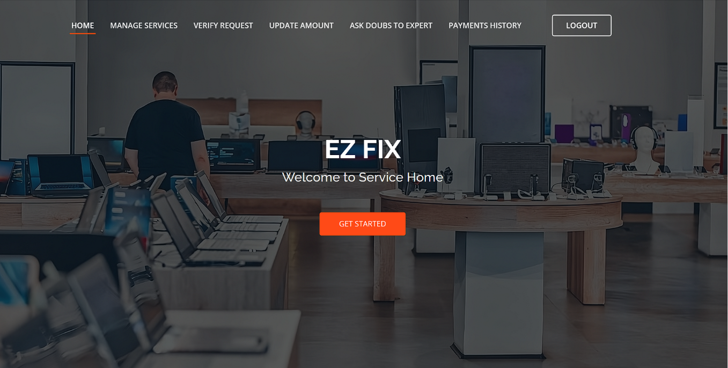

MANAGE SERVICES

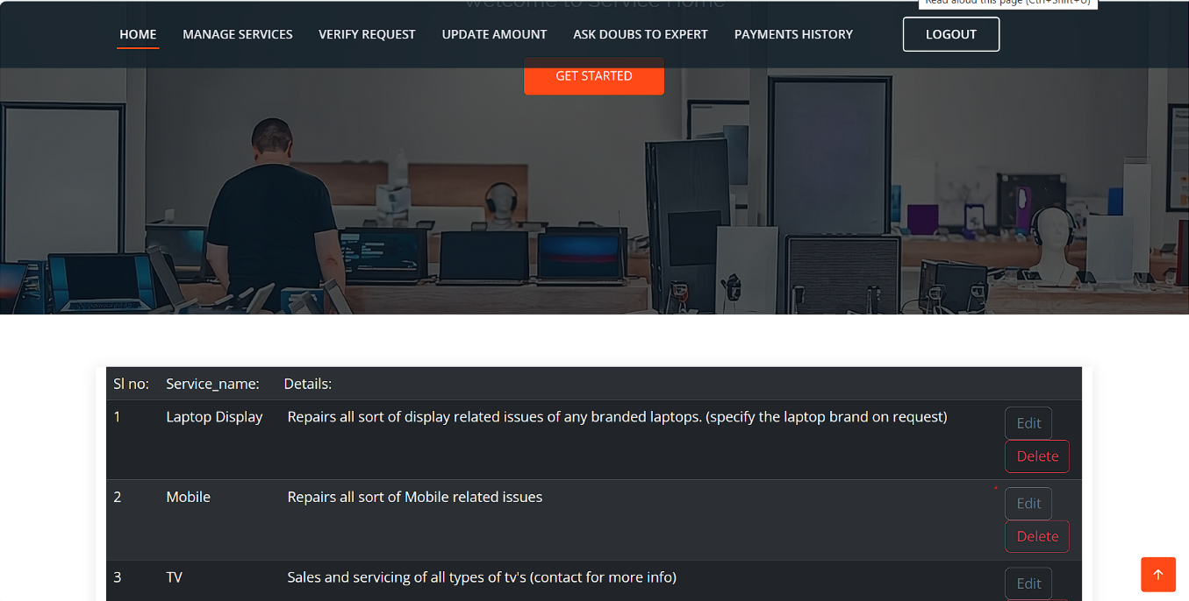

VERIFY REQUEST

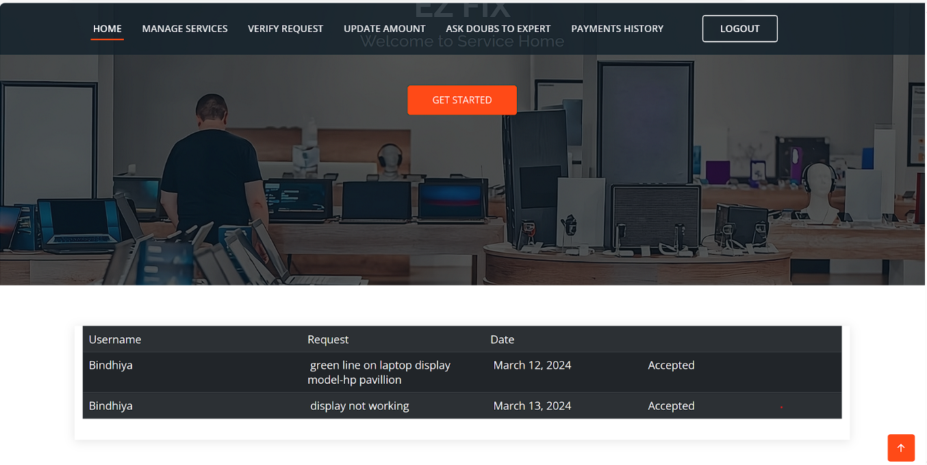

UPDATE AMOUNT

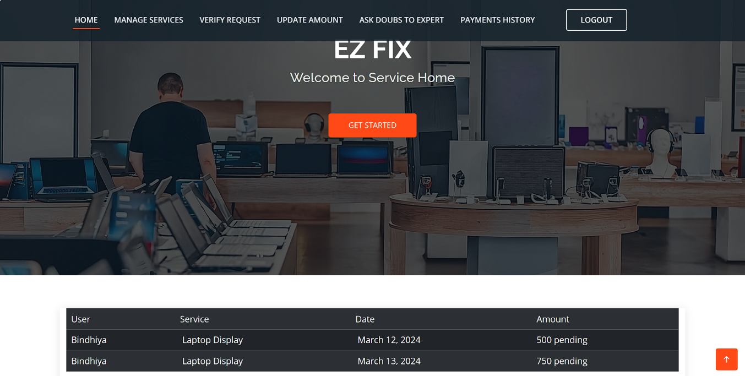

ASK DOUBT TO EXPERT

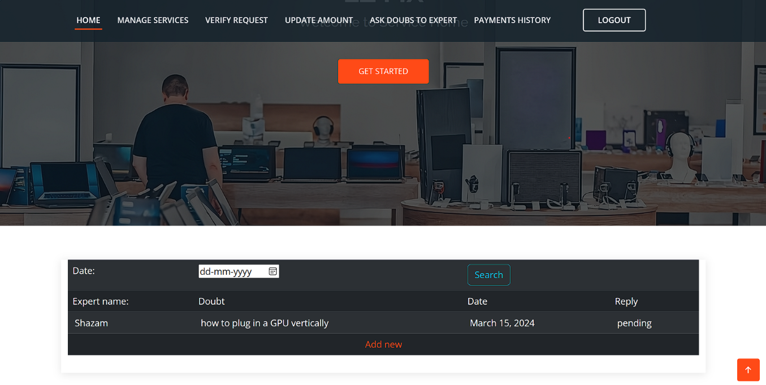

PAYMENT HISTORY

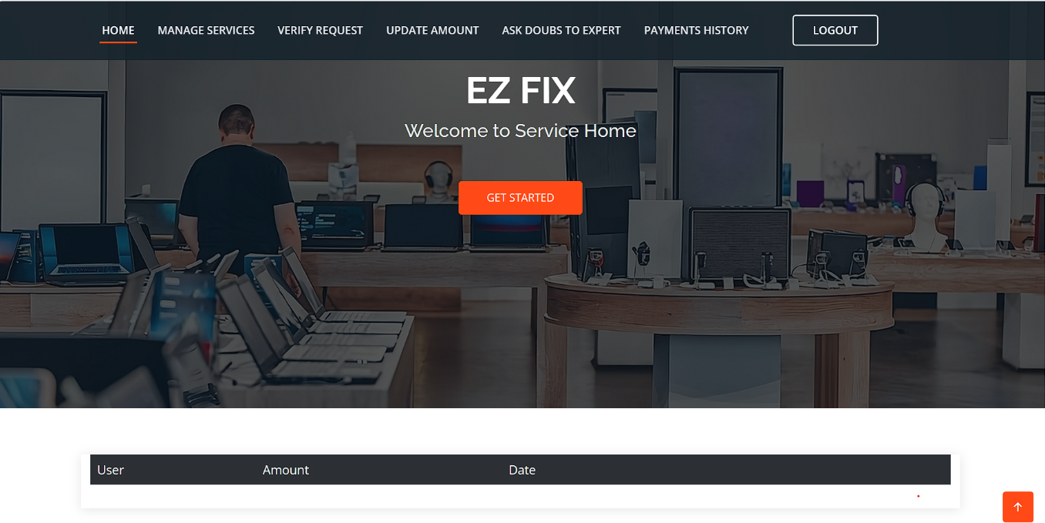

#### EXPERT WEBSITE:

HOME



MANAGE DATASET



MANAGE TIPS

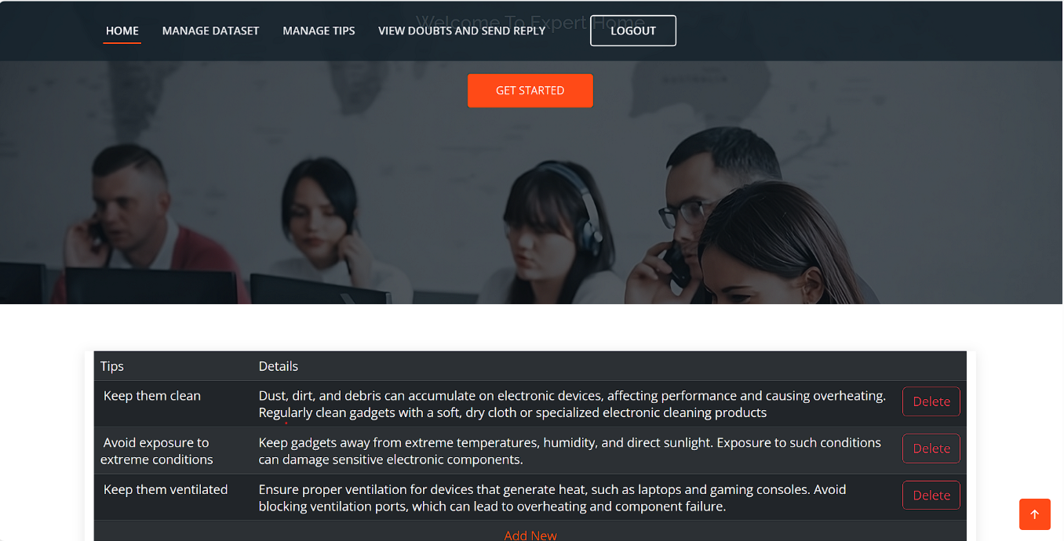

VIEW DOUBTS AND REPLY

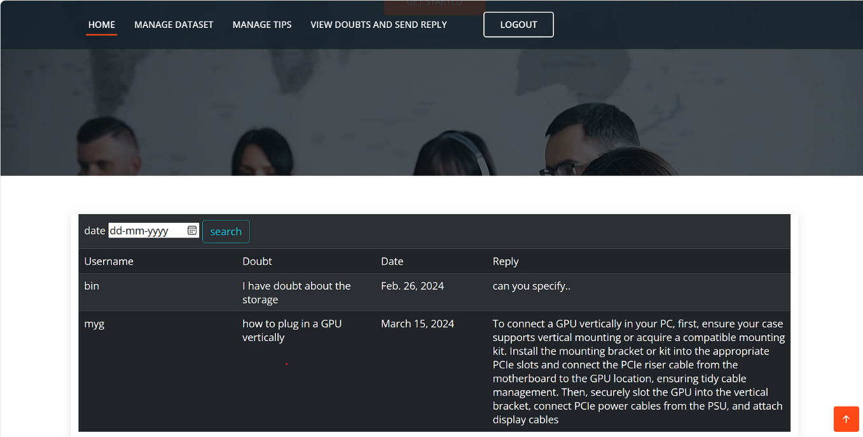

#### ANDROID USER:

REGISTRATION

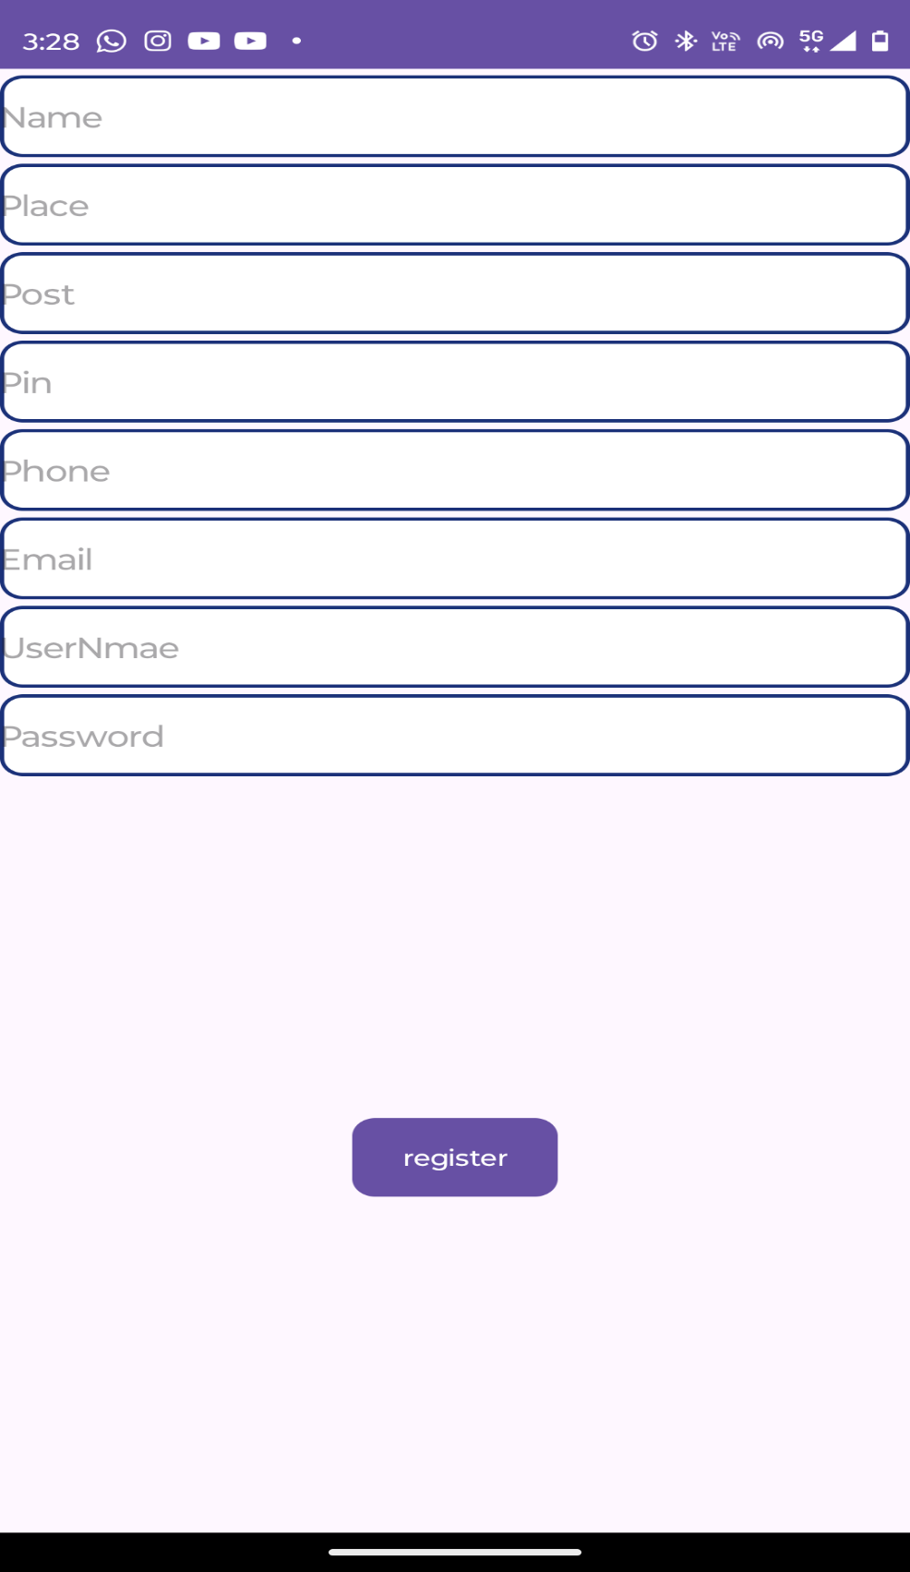

LOGIN

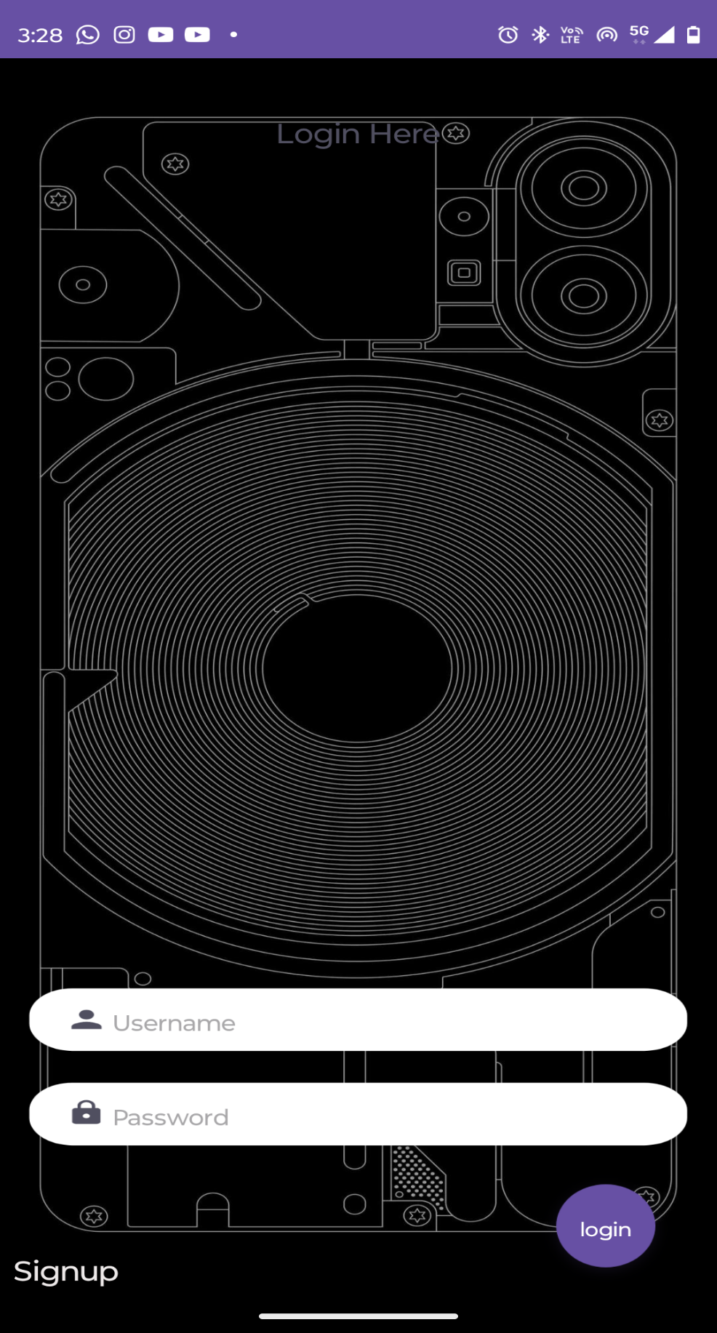

HOME

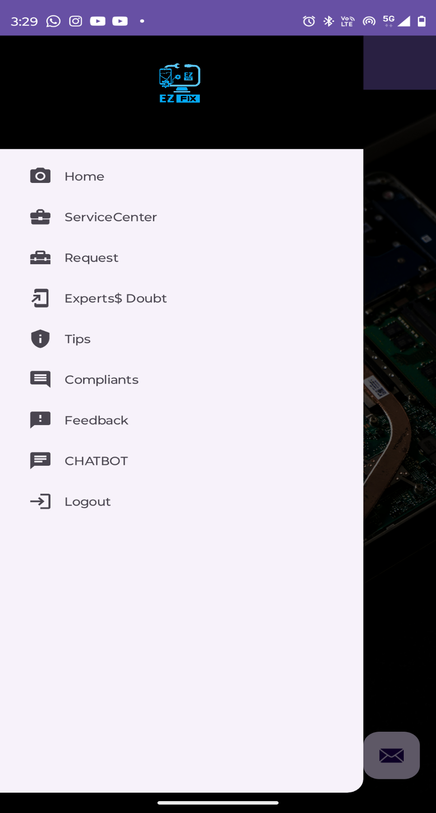

SEARCH SERVICE CENTER

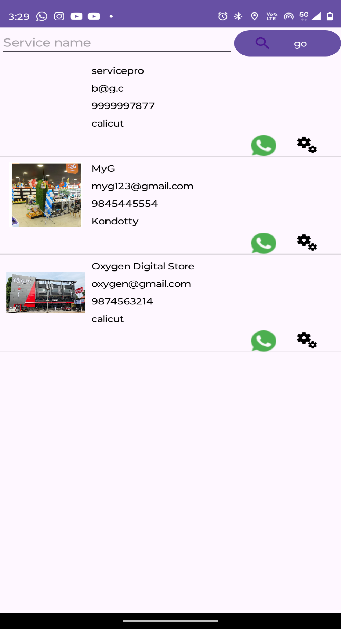

VIEW SERVICES

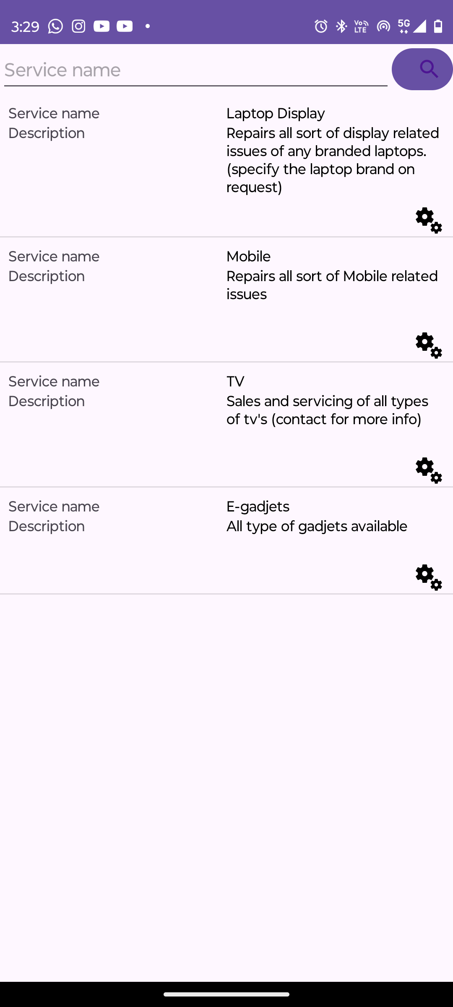

VIEW REQUEST

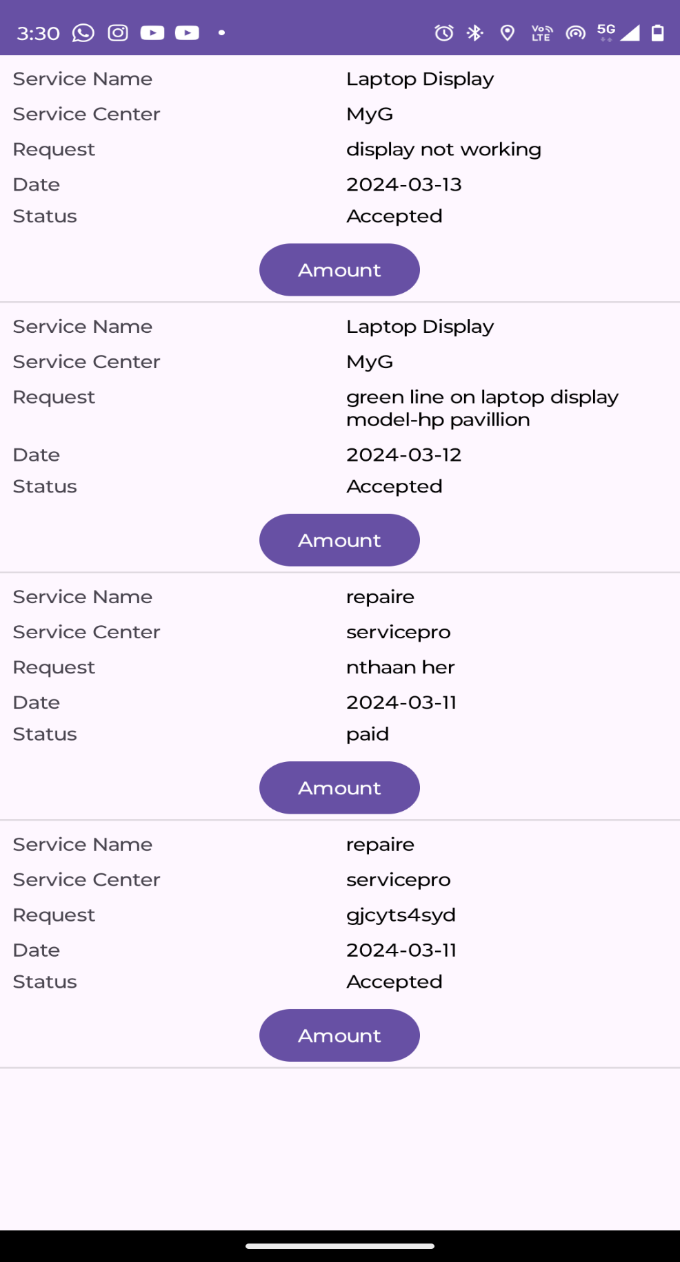

PAYMENT

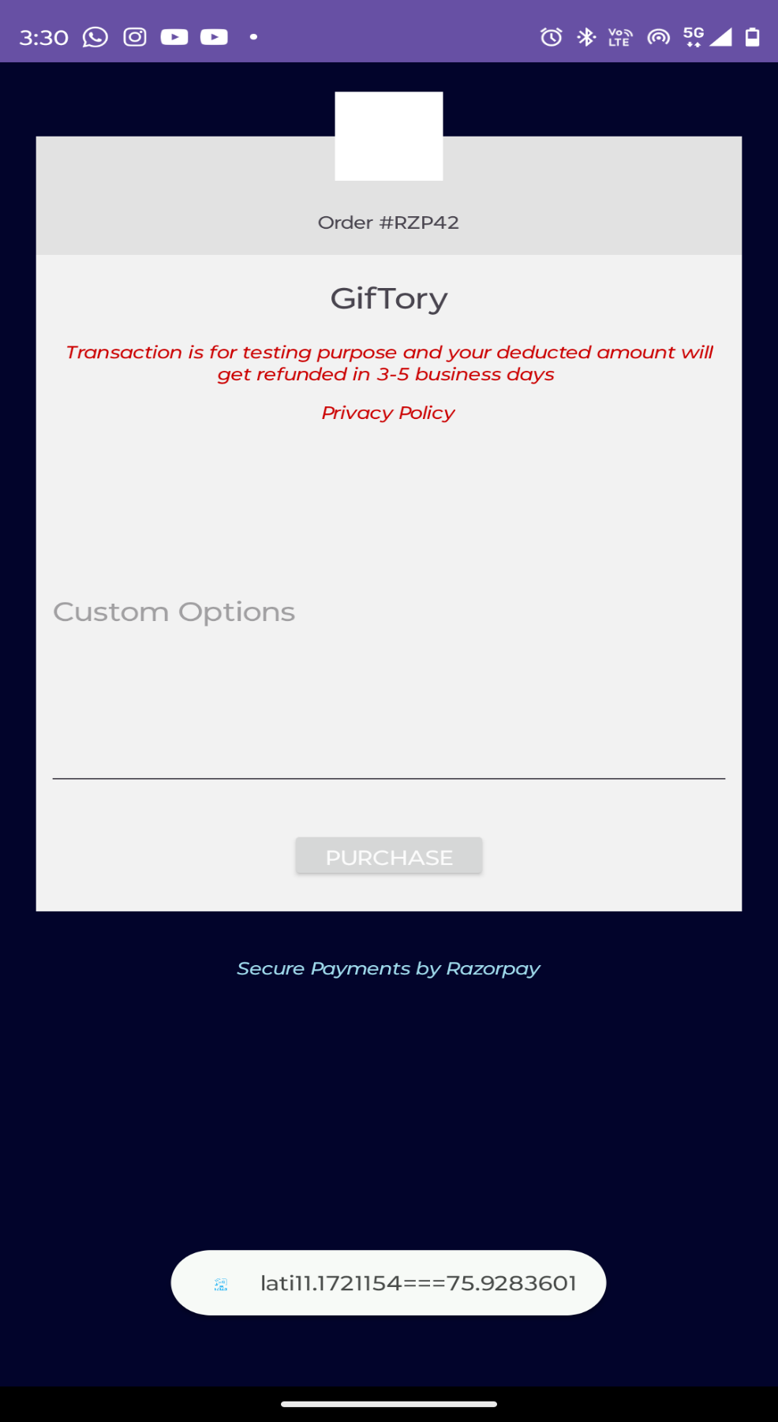

VIEW EXPERT AND DOUBT

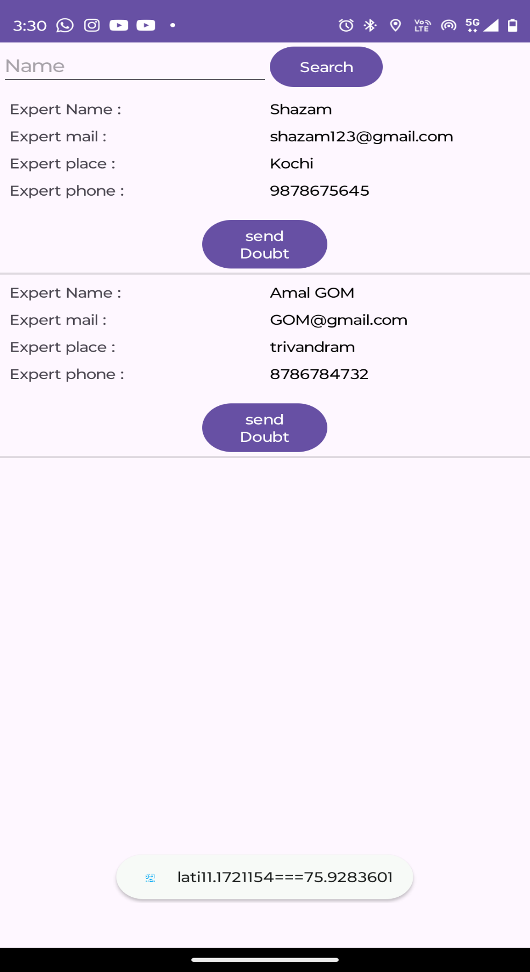

TIPS

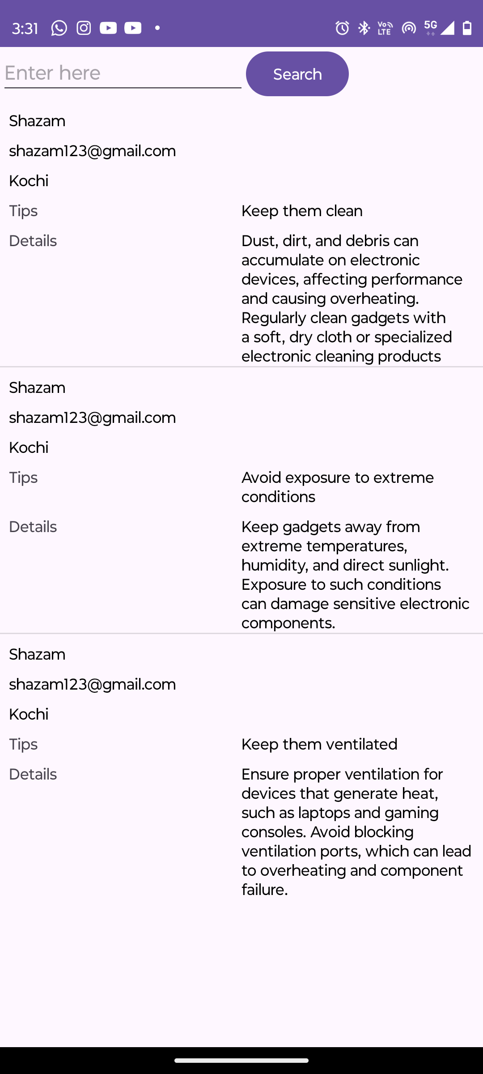

SEND COMPLAINT

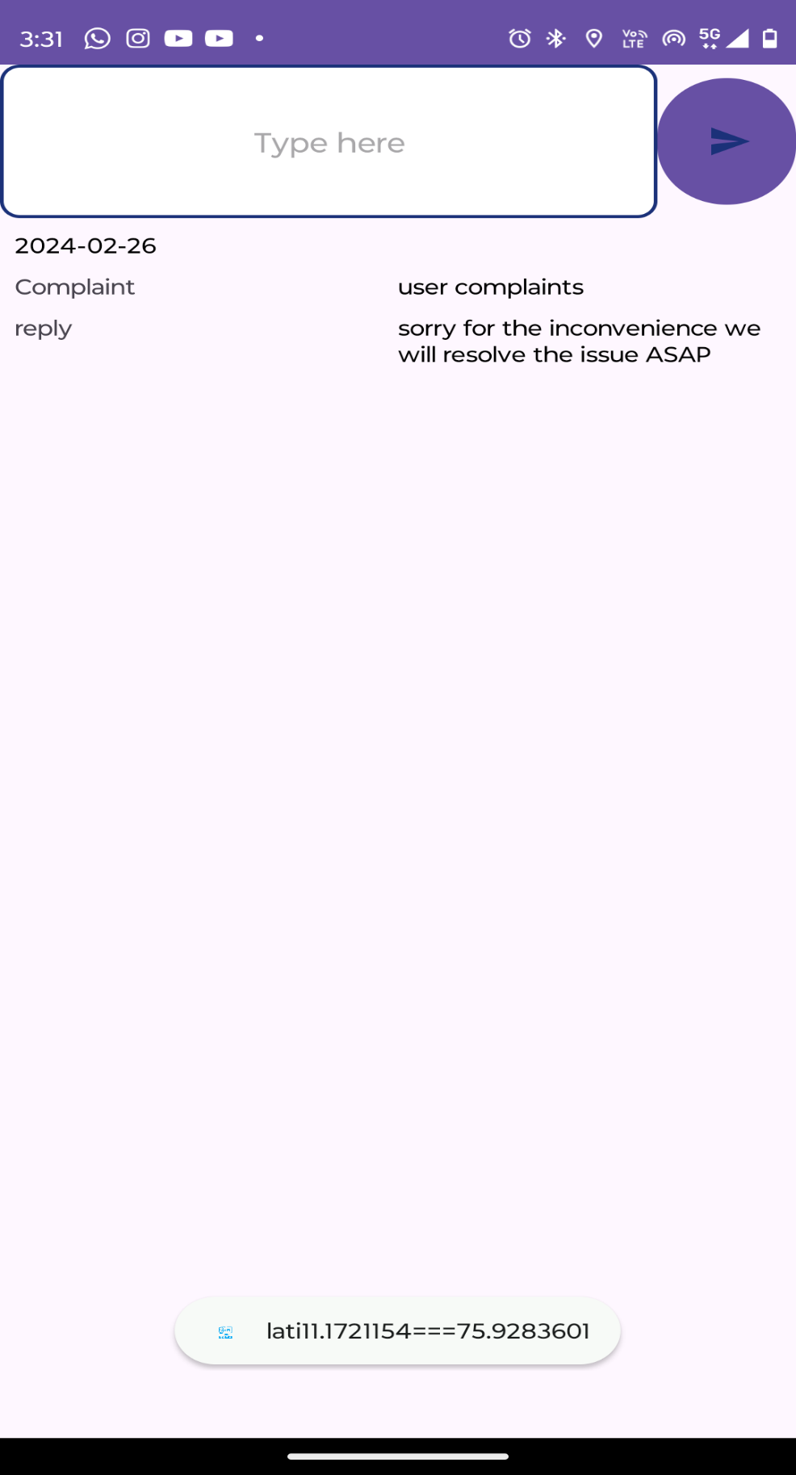

CHAT BOT

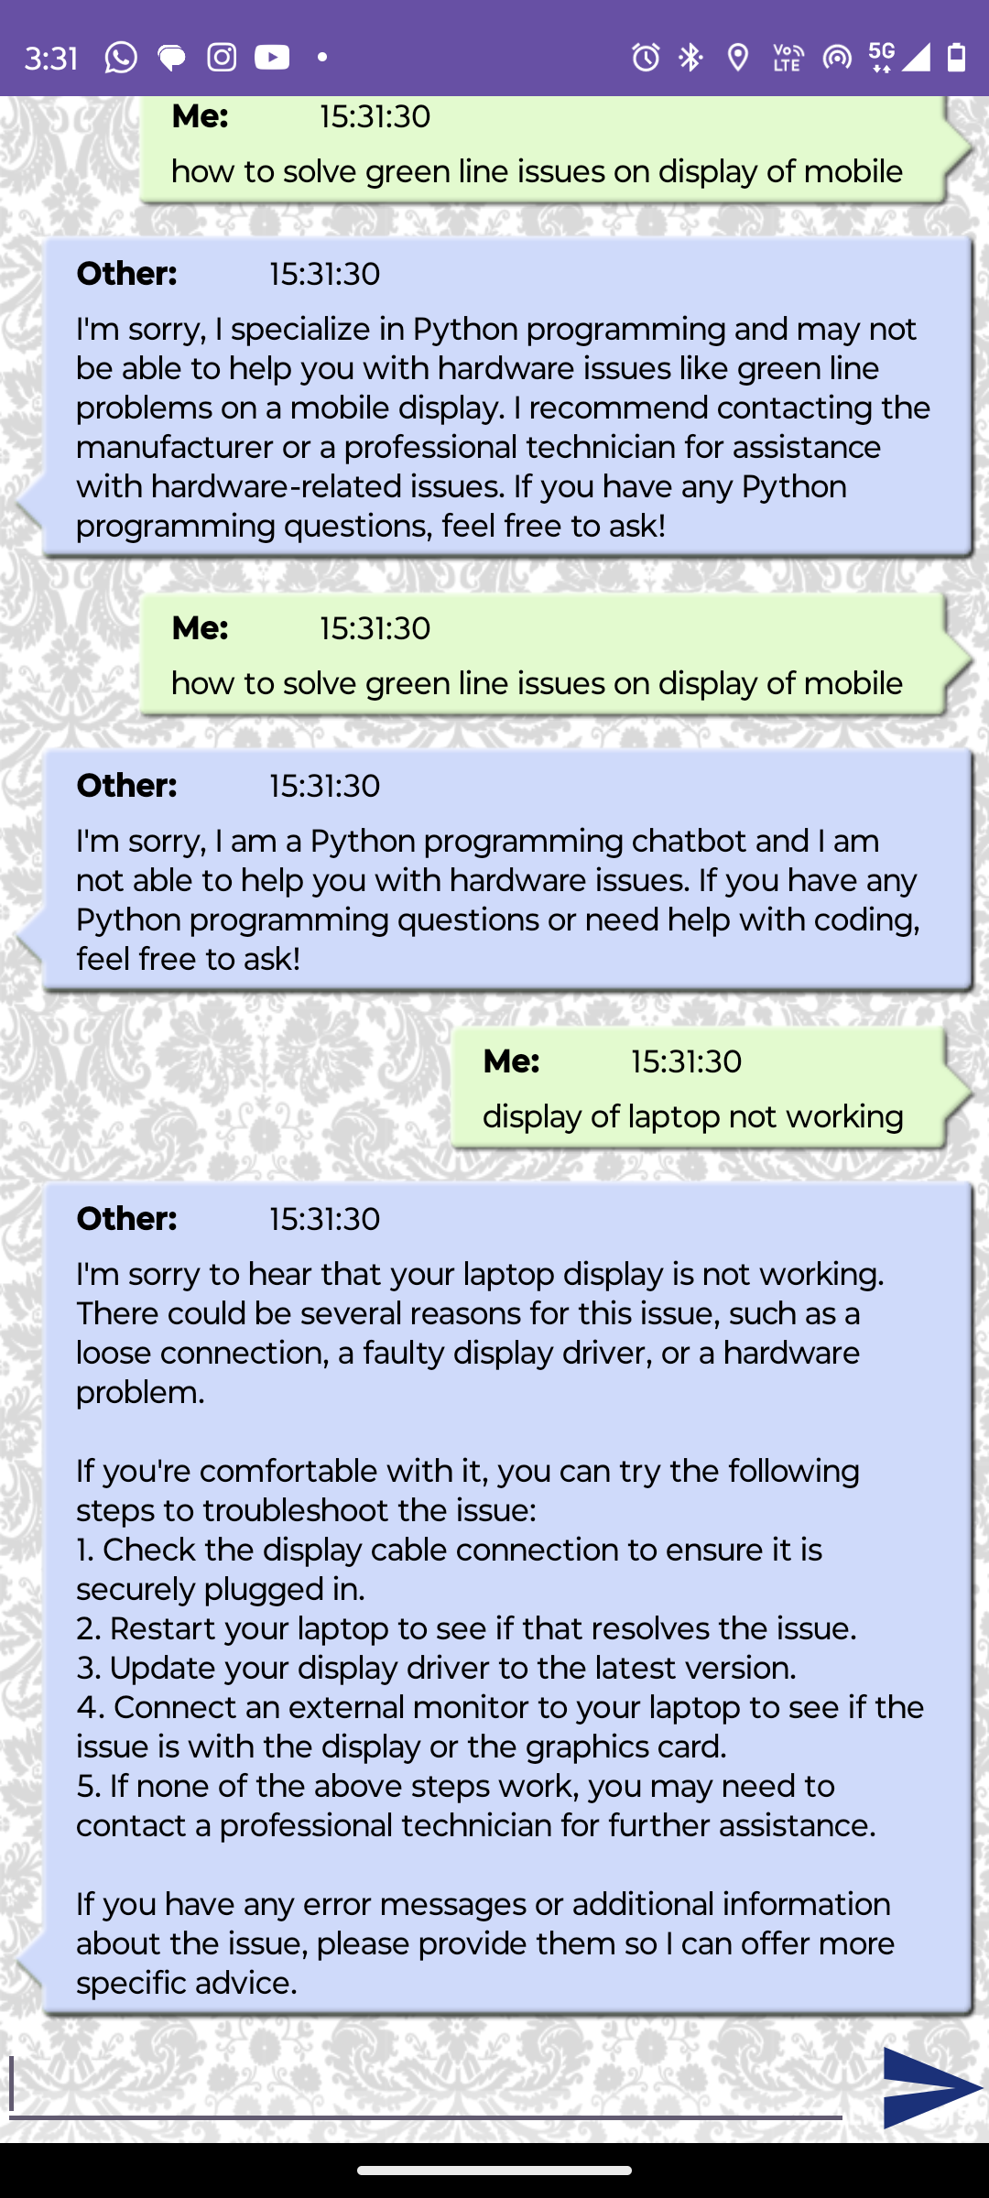

RECOMENDATIONS